

Cause of Death

Submitted by:

Rakesh Shinde

**INTRODUCTION**

**Problem Statement:**

A straightforward way to assess the health status of a population is to focus on mortality – or concepts like child mortality or life expectancy, which are based on mortality estimates. A focus on mortality, however, does not take into account that the burden of diseases is not only that they kill people, but that they cause suffering to people who live with them. Assessing health outcomes by both mortality and morbidity (the prevalent diseases) provides a more encompassing view on health outcomes. This is the topic of this entry. The sum of mortality and morbidity is referred to as the ‘burden of disease’ and can be measured by a metric called ‘Disability Adjusted Life Years‘(DALYs). DALYs are measuring lost health and are a standardized metric that allow for direct comparisons of disease burdens of different diseases across countries, between different populations, and over time. Conceptually, one DALY is the equivalent of losing one year in good health because of either premature death or disease or disability. One DALY represents one lost year of healthy life. The first ‘Global Burden of Disease’ (GBD) was GBD 1990 and the DALY metric was prominently featured in the World Bank’s 1993 World Development Report. Today it is published by both the researchers at the Institute of Health Metrics and Evaluation (IHME) and the ‘Disease Burden Unit’ at the World Health Organization (WHO), which was created in 1998. The IHME continues the work that was started in the early 1990s and publishes the Global Burden of Disease study.

**Data Loading to Jupyter**

* Dataset loaded to Jupyter Notebook for further analysis

**Uderstanding the Dataset**

In this Dataset, we have Historical Data of different cause of deaths for all ages around the World. The key features of this Dataset are: Meningitis, Alzheimer's Disease and Other Dementias, Parkinson's Disease, Nutritional Deficiencies, Malaria, Drowning, Interpersonal Violence, Maternal Disorders, HIV/AIDS, Drug Use Disorders, Tuberculosis, Cardiovascular Diseases, Lower Respiratory Infections, Neonatal Disorders, Alcohol Use Disorders, Self-harm, Exposure to Forces of Nature, Diarrheal Diseases, Environmental Heat and Cold Exposure, Neoplasms, Conflict and Terrorism, Diabetes Mellitus, Chronic Kidney Disease, Poisonings, Protein-Energy Malnutrition, Road Injuries, Chronic Respiratory Diseases, Cirrhosis and Other Chronic Liver Diseases, Digestive Diseases, Fire, Heat, and Hot Substances, Acute Hepatitis.

**Dataset Glossary (Column-wise)**

01. Country/Territory - Name of the Country/Territory

02. Code - Country/Territory Code

03. Year - Year of the Incident

04. Meningitis - No. of People died from Meningitis

05. Alzheimer's Disease and Other Dementias - No. of People died from Alzheimer's Disease and Other Dementias

06. Parkinson's Disease - No. of People died from Parkinson's Disease

07. Nutritional Deficiencies - No. of People died from Nutritional Deficiencies

08. Malaria - No. of People died from Malaria

09. Drowning - No. of People died from Drowning

10. Interpersonal Violence - No. of People died from Interpersonal Violence

11. Maternal Disorders - No. of People died from Maternal Disorders

12. Drug Use Disorders - No. of People died from Drug Use Disorders

13. Tuberculosis - No. of People died from Tuberculosis

14. Cardiovascular Diseases - No. of People died from Cardiovascular Diseases

15. Lower Respiratory Infections - No. of People died from Lower Respiratory Infections

16. Neonatal Disorders - No. of People died from Neonatal Disorders

17. Alcohol Use Disorders - No. of People died from Alcohol Use Disorders

18. Self-harm - No. of People died from Self-harm

19. Exposure to Forces of Nature - No. of People died from Exposure to Forces of Nature

20. Diarrheal Diseases - No. of People died from Diarrheal Diseases

21. Environmental Heat and Cold Exposure - No. of People died from Environmental Heat and Cold Exposure

22. Neoplasms - No. of People died from Neoplasms

23. Conflict and Terrorism - No. of People died from Conflict and Terrorism

24. Diabetes Mellitus - No. of People died from Diabetes Mellitus

25. Chronic Kidney Disease - No. of People died from Chronic Kidney Disease

26. Poisonings - No. of People died from Poisoning

27. Protein-Energy Malnutrition - No. of People died from Protein-Energy Malnutrition

28. Chronic Respiratory Diseases - No. of People died from Chronic Respiratory Diseases

29. Cirrhosis and Other Chronic Liver Diseases - No. of People died from Cirrhosis and Other Chronic Liver Diseases

30. Digestive Diseases - No. of People died from Digestive Diseases

31. Fire, Heat, and Hot Substances - No. of People died from Fire or Heat or any Hot Substances

32. Acute Hepatitis - No. of People died from Acute Hepatitis

**Data Type**

The data types are checked and found to be as the mentioned data following are the type of each column

Country/Territory object

Code object

Year int64

Meningitis int64

Alzheimer's Disease and Other Dementias int64

Parkinson's Disease int64

Nutritional Deficiencies int64

Malaria int64

Drowning int64

Interpersonal Violence int64

Maternal Disorders int64

HIV/AIDS int64

Drug Use Disorders int64

Tuberculosis int64

Cardiovascular Diseases int64

Lower Respiratory Infections int64

Neonatal Disorders int64

Alcohol Use Disorders int64

Self-harm int64

Exposure to Forces of Nature int64

Diarrheal Diseases int64

Environmental Heat and Cold Exposure int64

Neoplasms int64

Conflict and Terrorism int64

Diabetes Mellitus int64

Chronic Kidney Disease int64

Poisonings int64

Protein-Energy Malnutrition int64

Road Injuries int64

Chronic Respiratory Diseases int64

Cirrhosis and Other Chronic Liver Diseases int64

Digestive Diseases int64

Fire, Heat, and Hot Substances int64

Acute Hepatitis int64

**Note: - Since the columns and the content in the column is having correct data types so need not to be checked for the void spaces and others similar type of cleaning**

**Null Values**

**Dataset is not having any null values**

**VISUALIZATION & FINDINGS**

**Highest no. of deaths in particular disease in descending order for countries**

Top 10 Countries with death Counter due to Meningitis

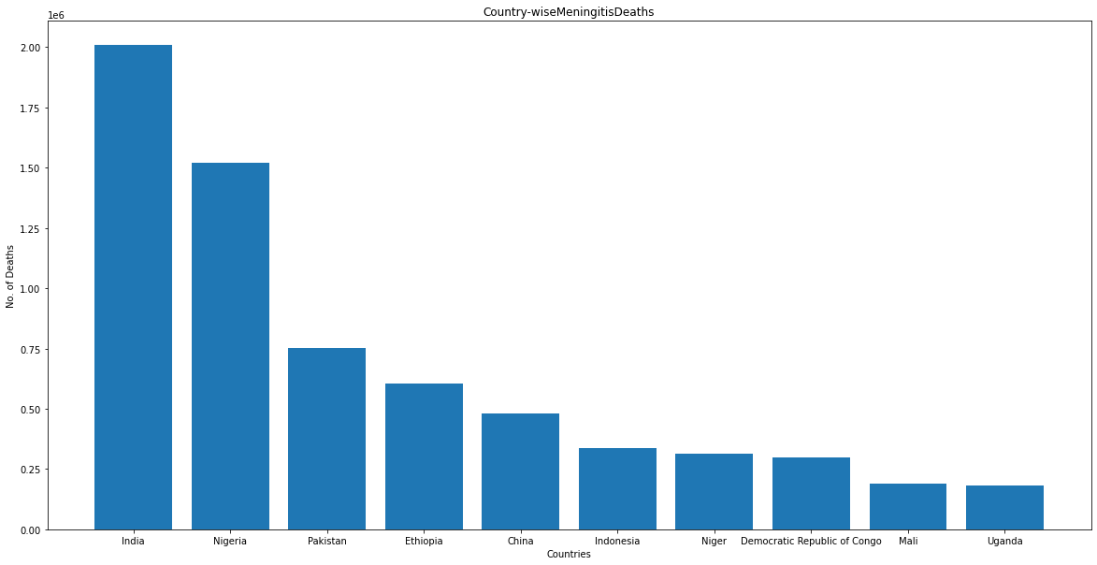

Top 10 Countries with death Counter due to Alzheimer's Disease and Other Dementias

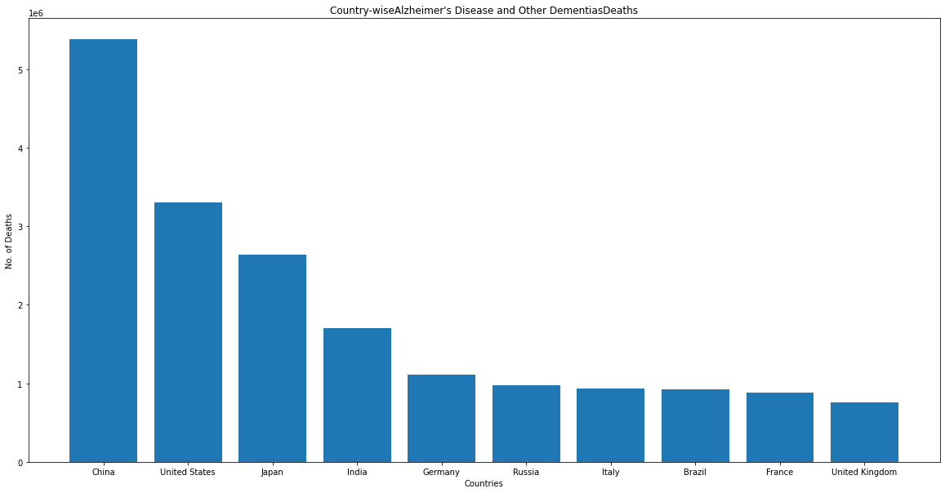

Top 10 Countries with death Counter due to Parkinson's Disease

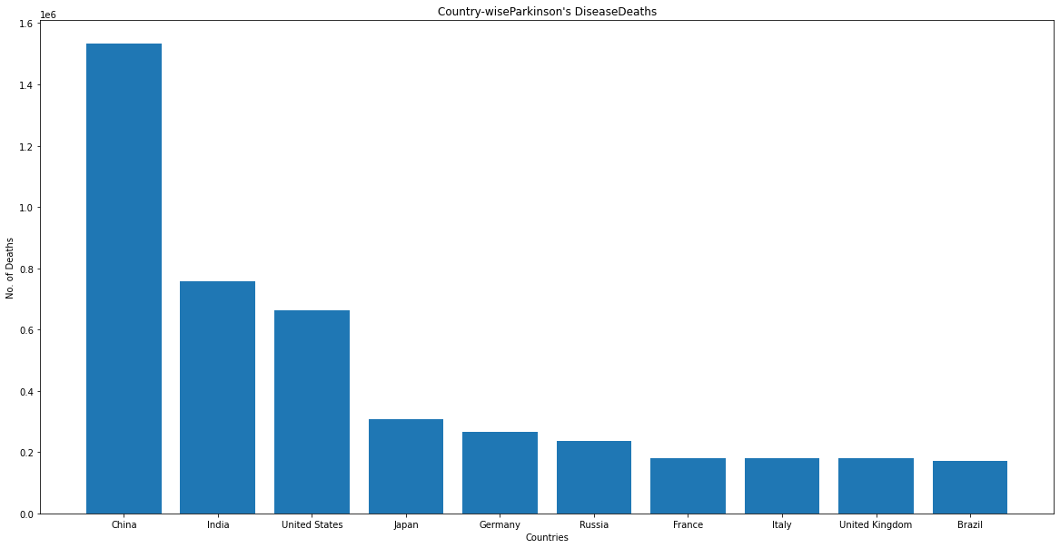

Top 10 Countries with death Counter due to Nutritional Deficiencies

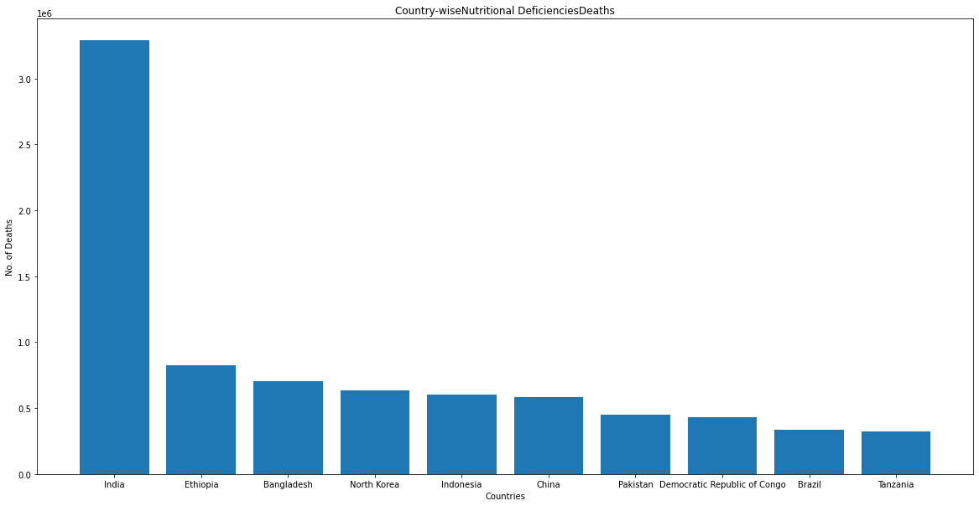

Top 10 Countries with death Counter due to Malaria

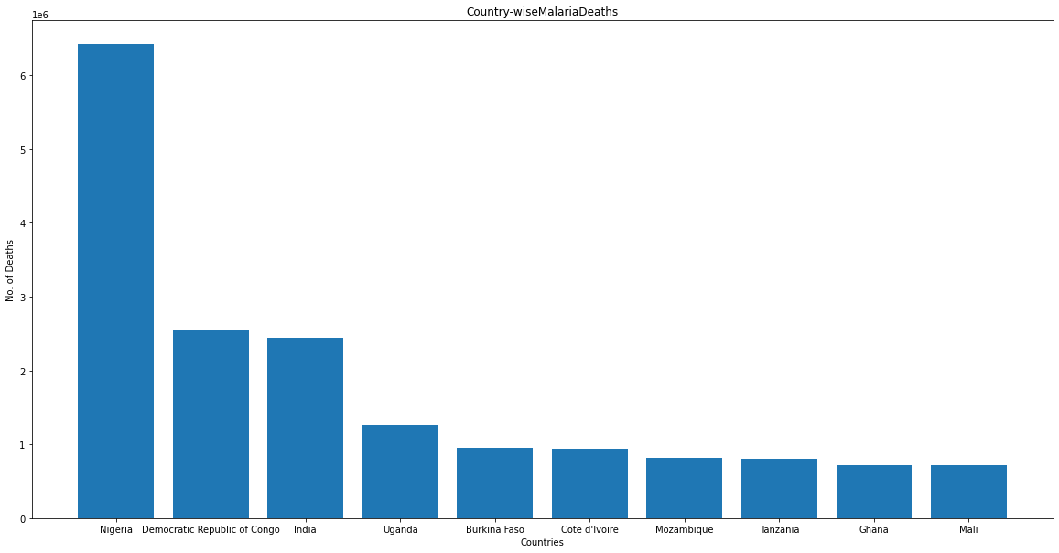

Top 10 Countries with death Counter due to Drowning

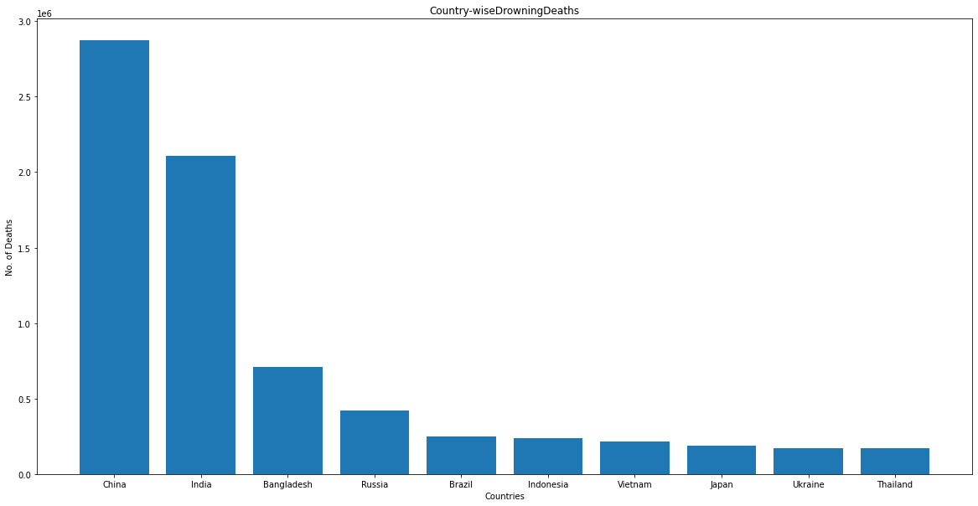

Top 10 Countries with death Counter due to Interpersonal Violence

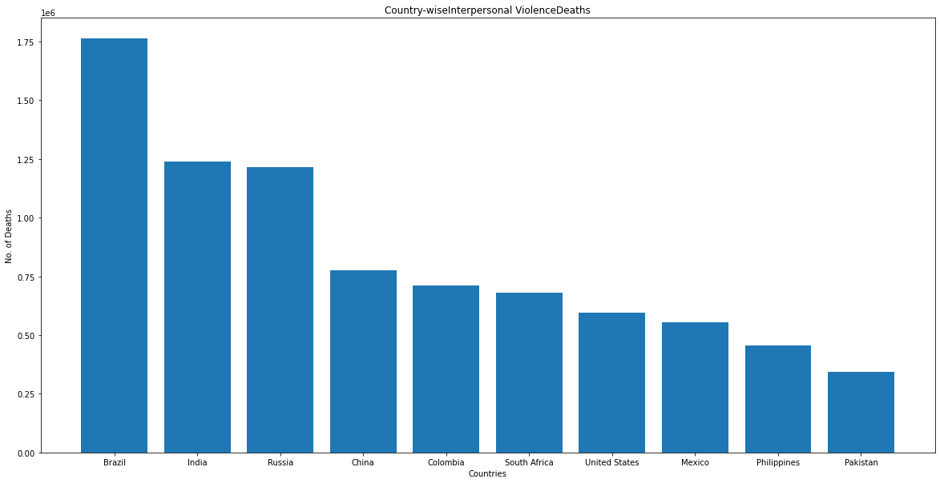

Top 10 Countries with death Counter due to Maternal Disorders

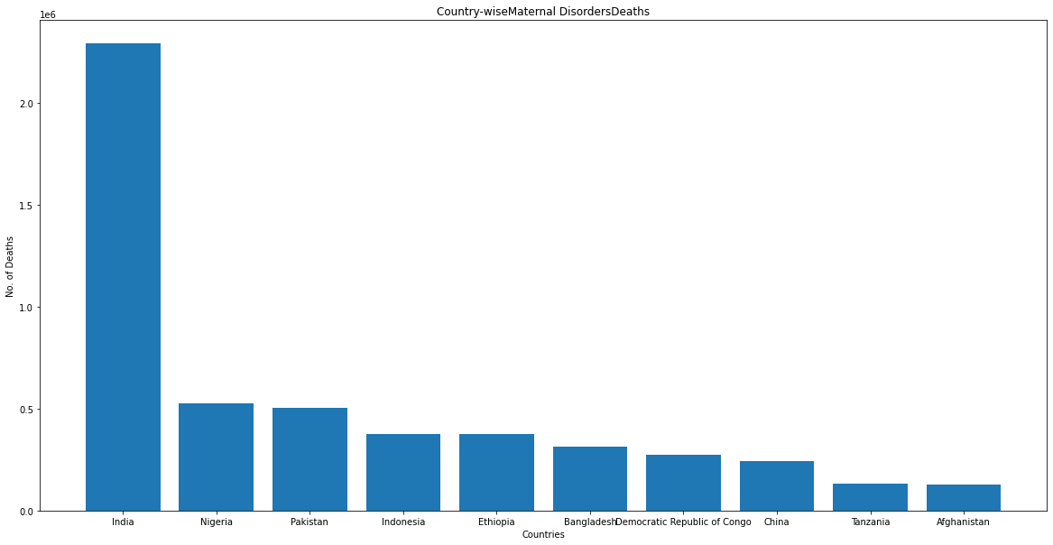

Top 10 Countries with death Counter due to HIV/AIDS

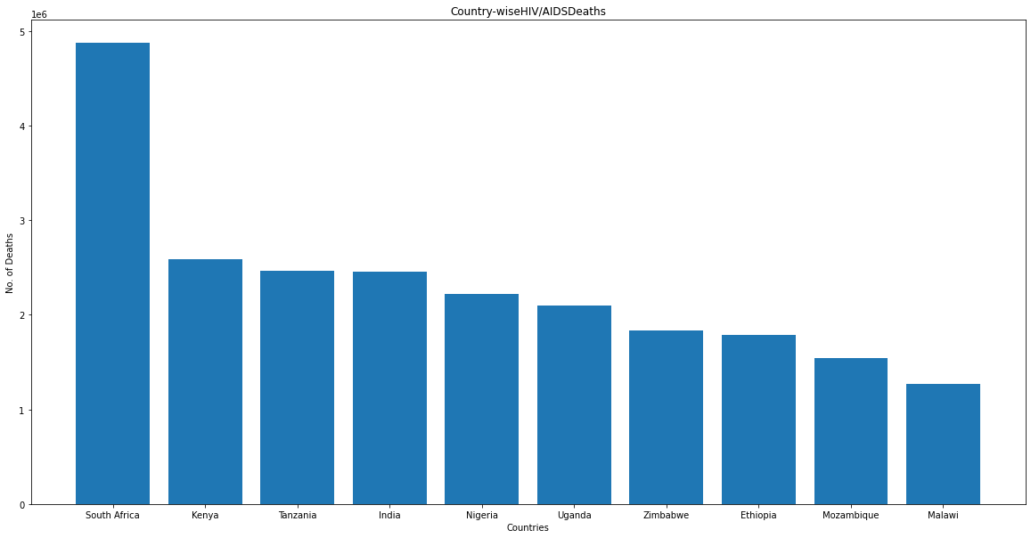

Top 10 Countries with death Counter due to Drug Use Disorders

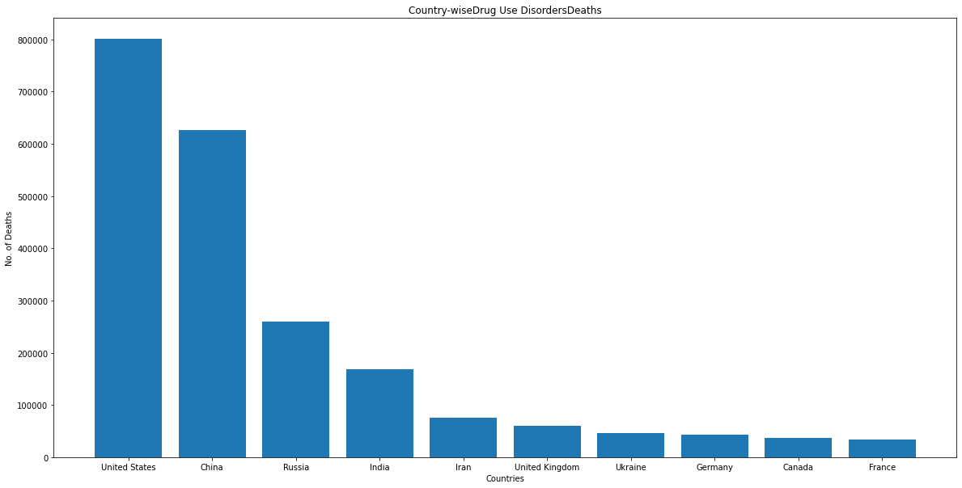

Top 10 Countries with death Counter due to Tuberculosis

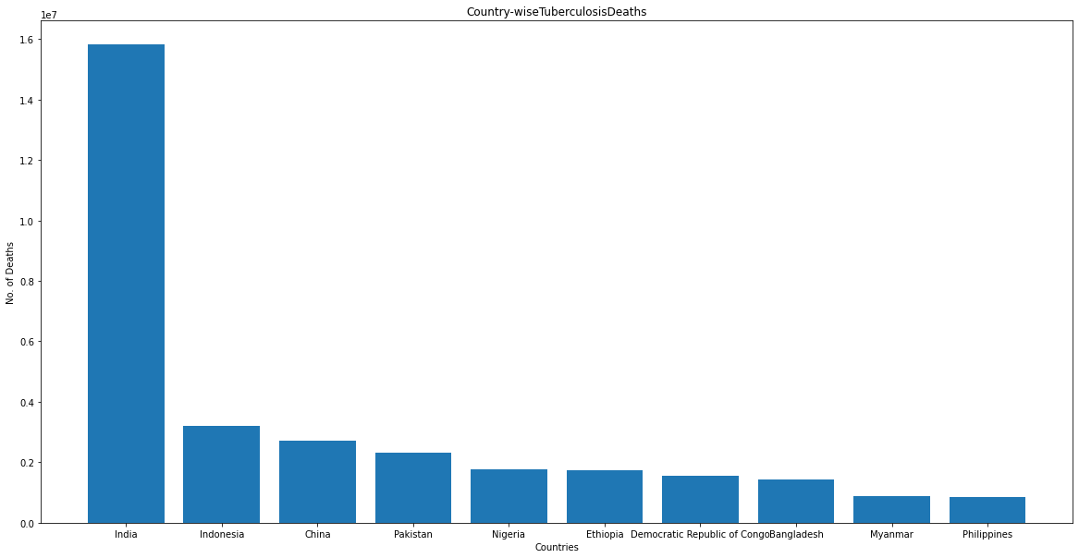

Top 10 Countries with death Counter due to cardiovascular diseases

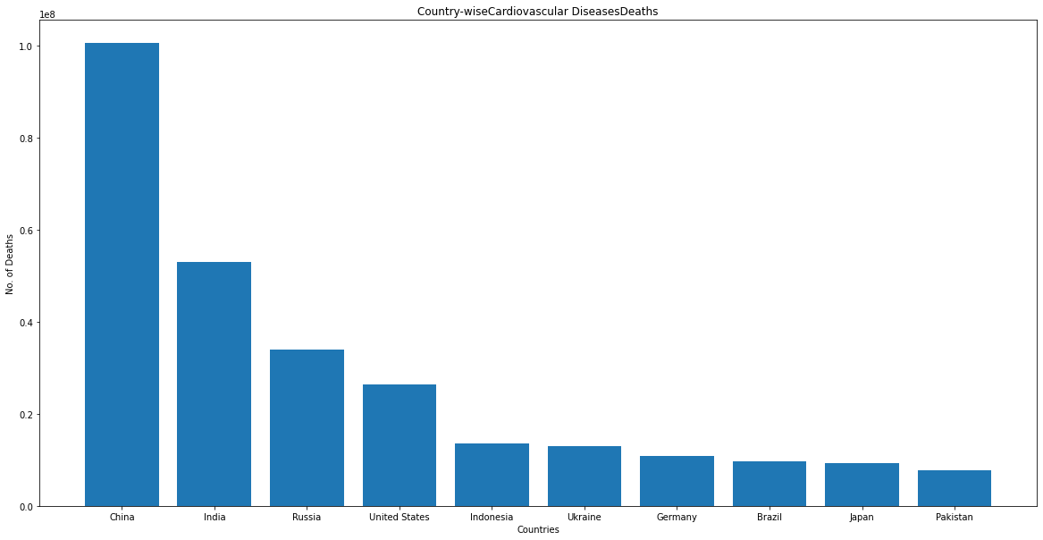

Top 10 Countries with death Counter due to Lower Respiratory Infections

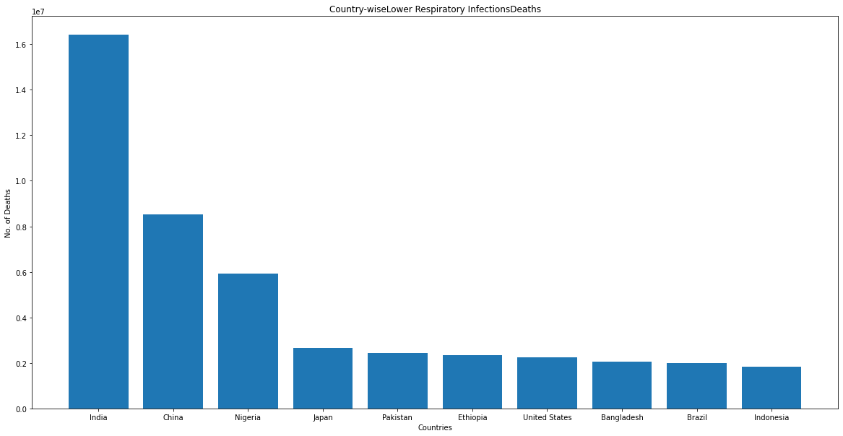

Top 10 Countries with death Counter due to Neonatal Disorders

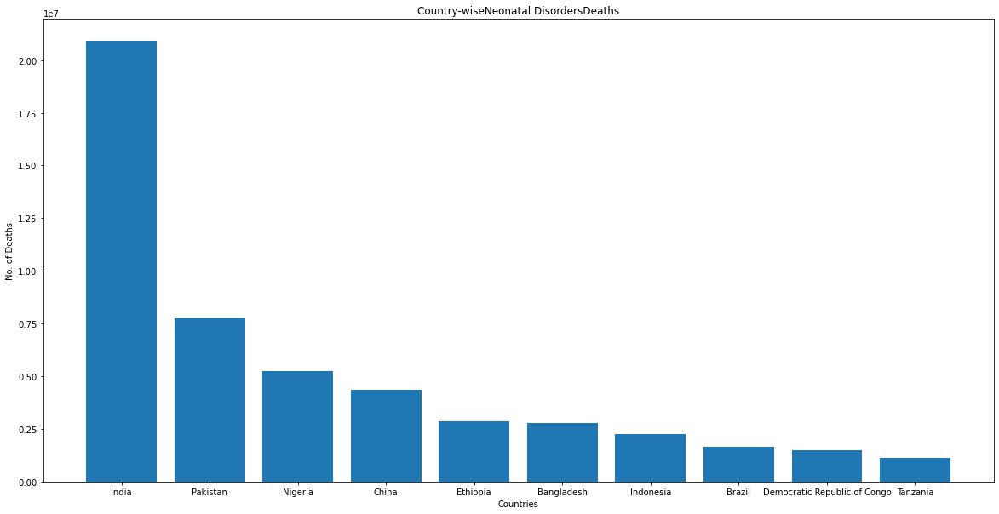

Top 10 Countries with death Counter due to Alcohol Use Disorders

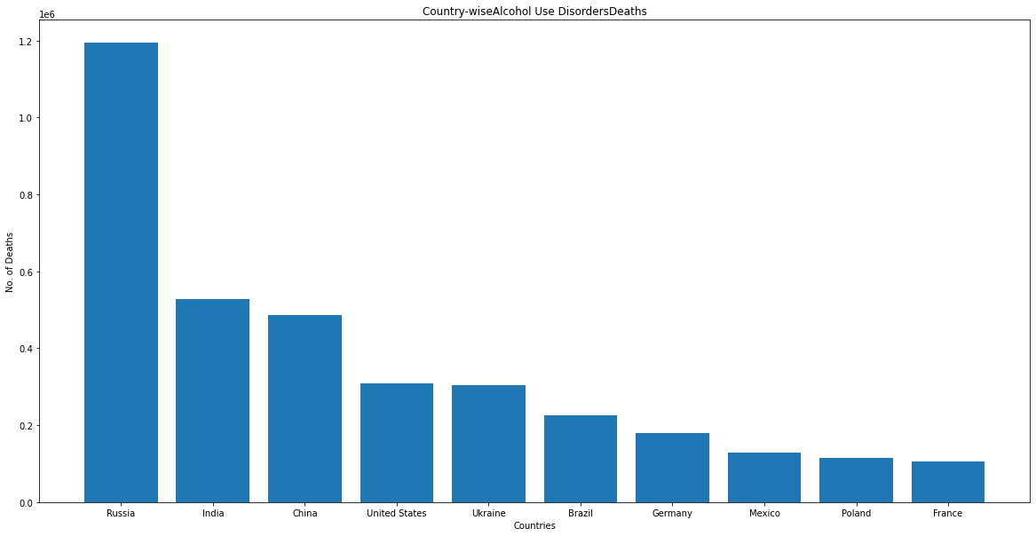

Top 10 Countries with death Counter due to Self-harm

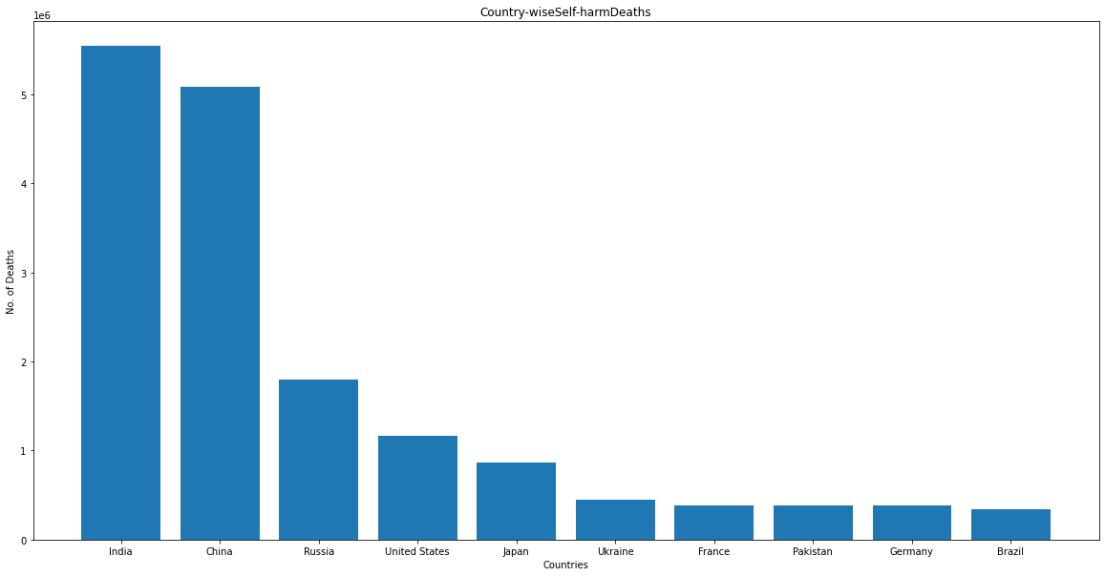

Top 10 Countries with death Counter due to Exposure to Forces of Nature

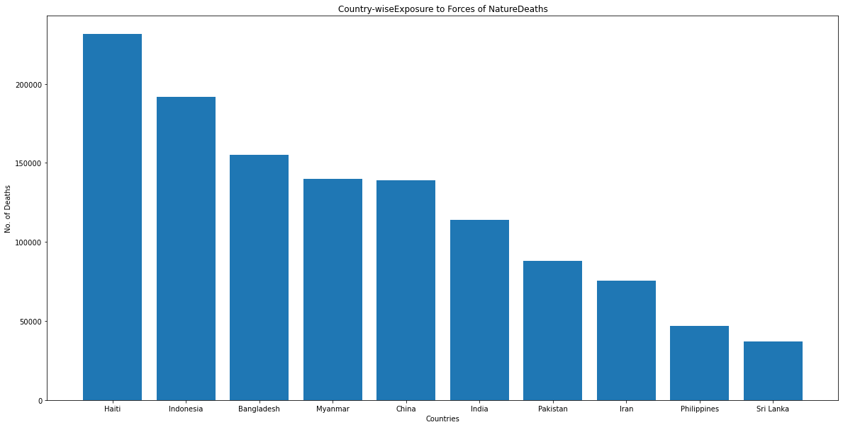

Top 10 Countries with death Counter due to Diarrheal Diseases

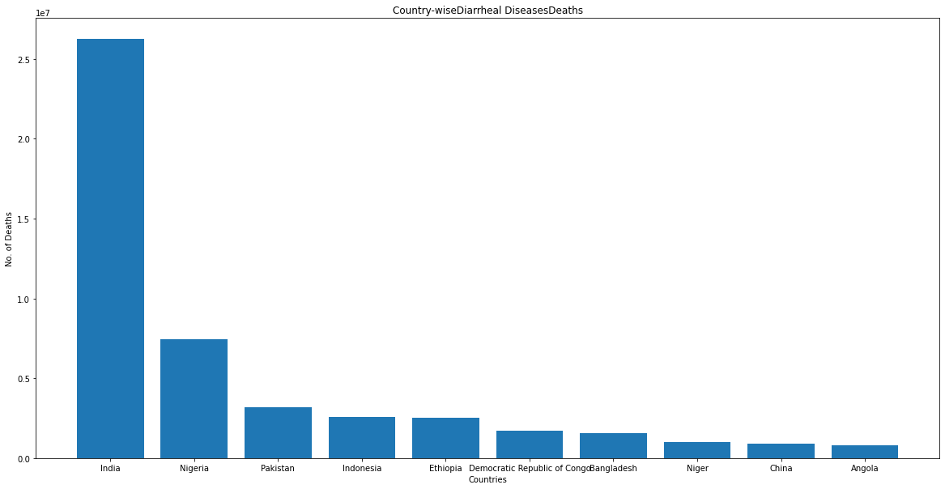

Top 10 Countries with death Counter due to Environmental Heat and Cold Exposure

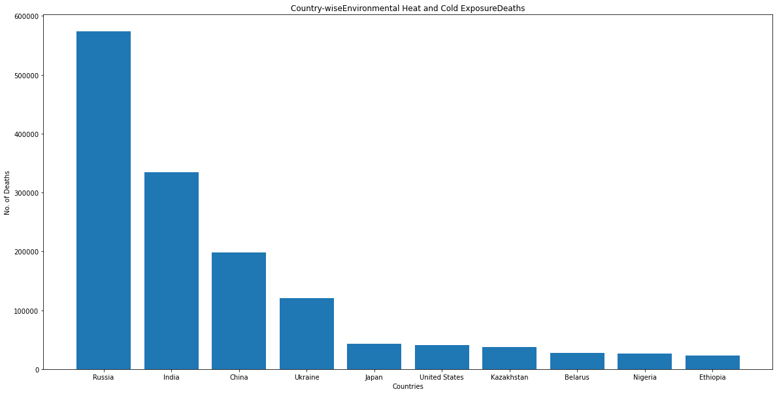

Top 10 Countries with death Counter due to Neoplasms

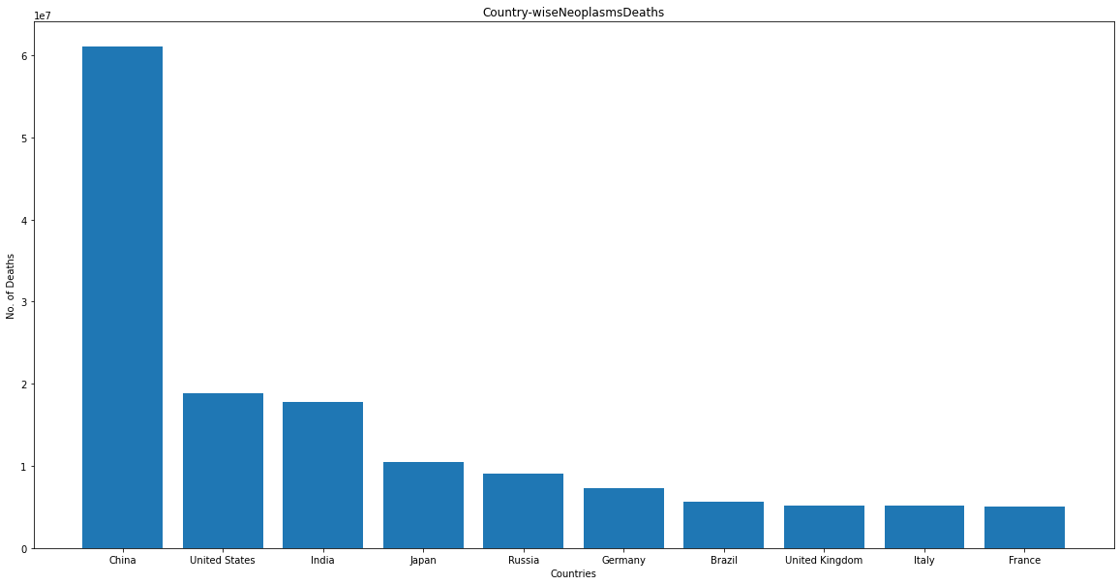

Top 10 Countries with death Counter due to Conflict and Terrorism

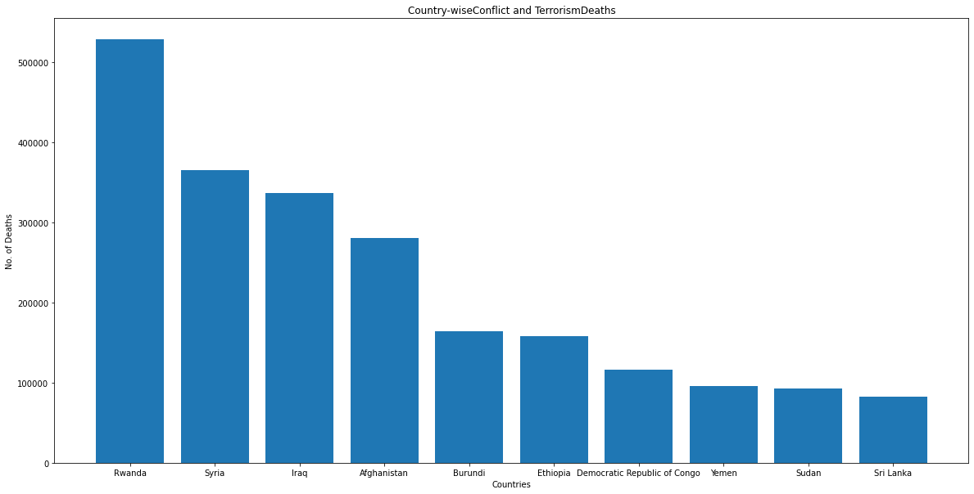

Top 10 Countries with death Counter due to Diabetes Mellitus

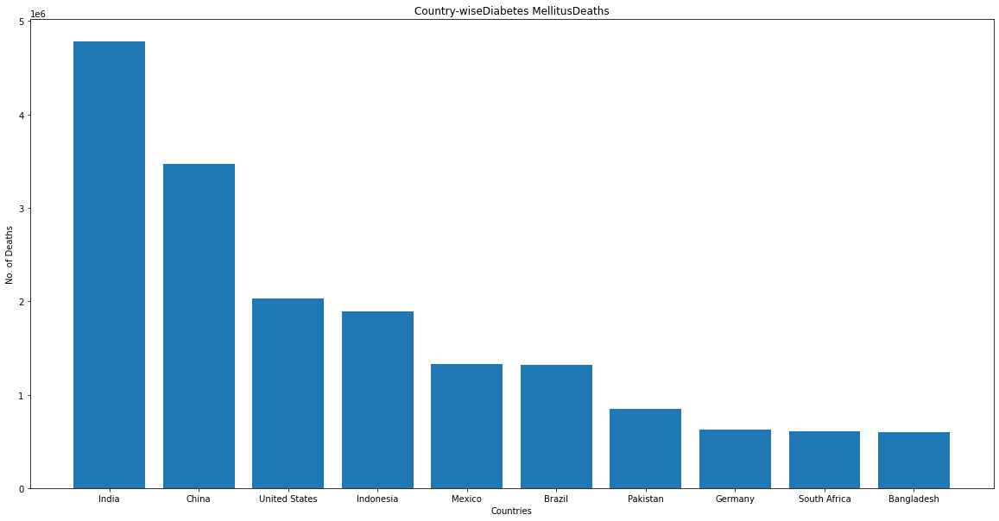

Top 10 Countries with death Counter due to Chronic Kidney Disease

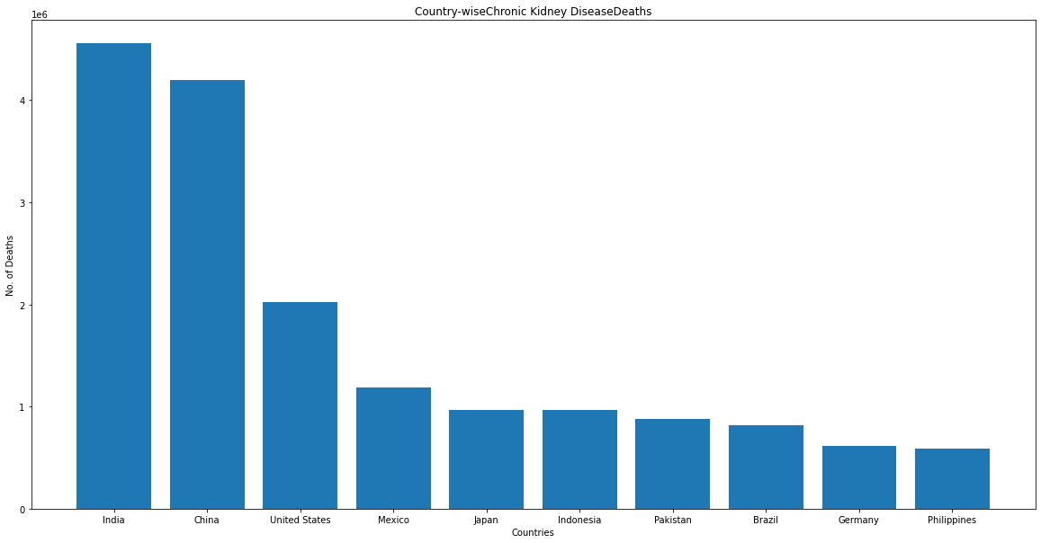

Top 10 Countries with death Counter due to Poisonings

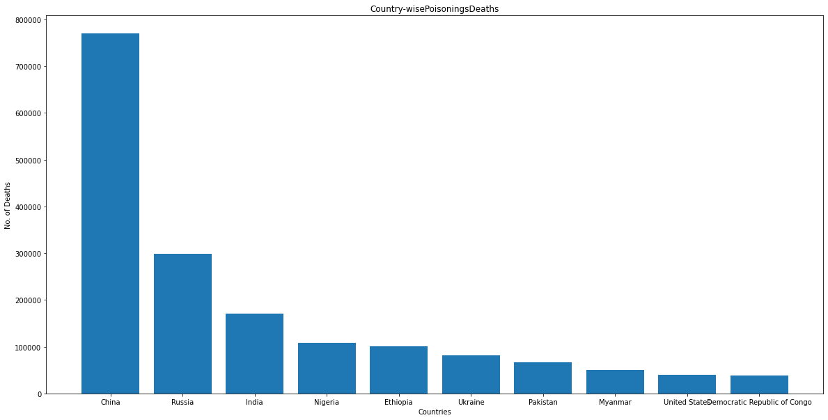

Top 10 Countries with death Counter due to Protein-Energy Malnutrition

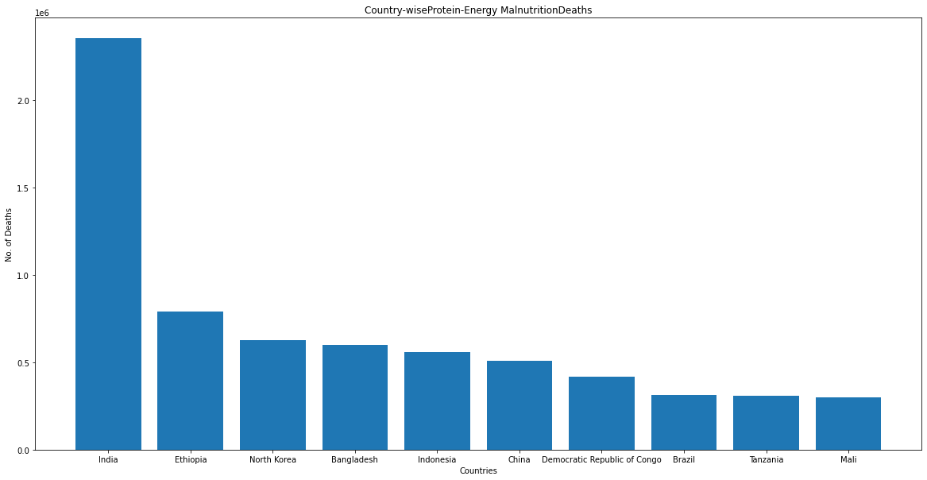

Top 10 Countries with death Counter due to Road Injuries

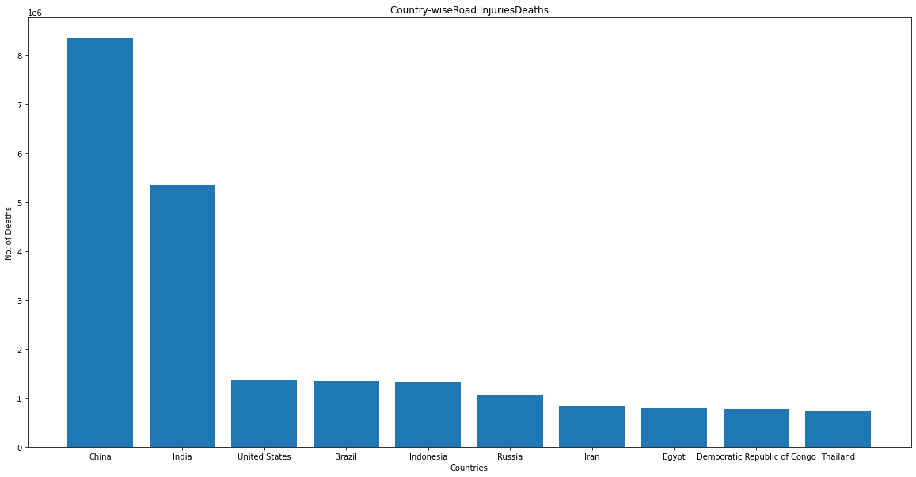

Top 10 Countries with death Counter due to Chronic Respiratory Diseases

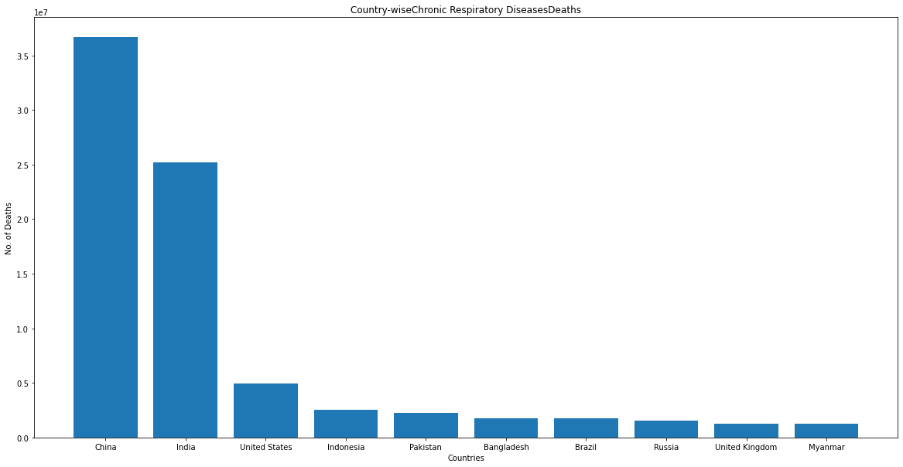

Top 10 Countries with death Counter due to Cirrhosis and Other Chronic Liver Diseases

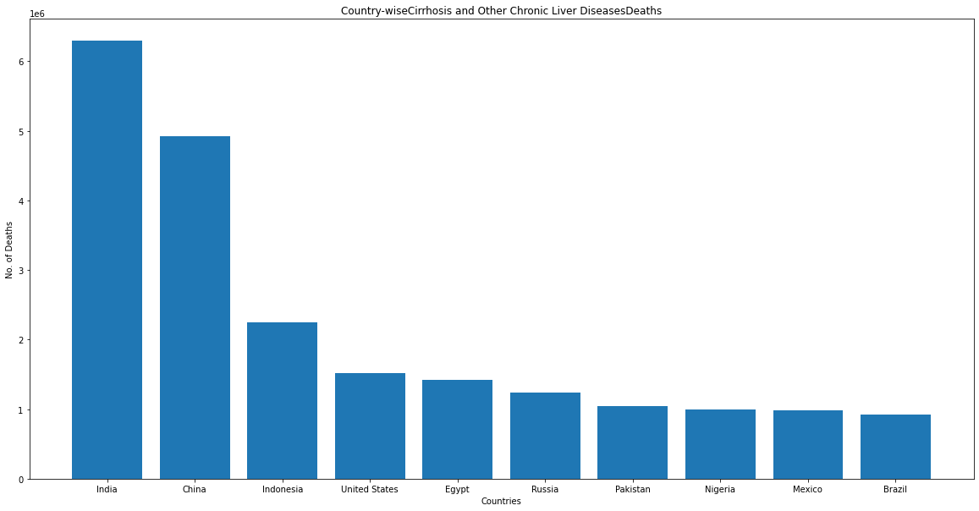

Top 10 Countries with death Counter due to Digestive Diseases

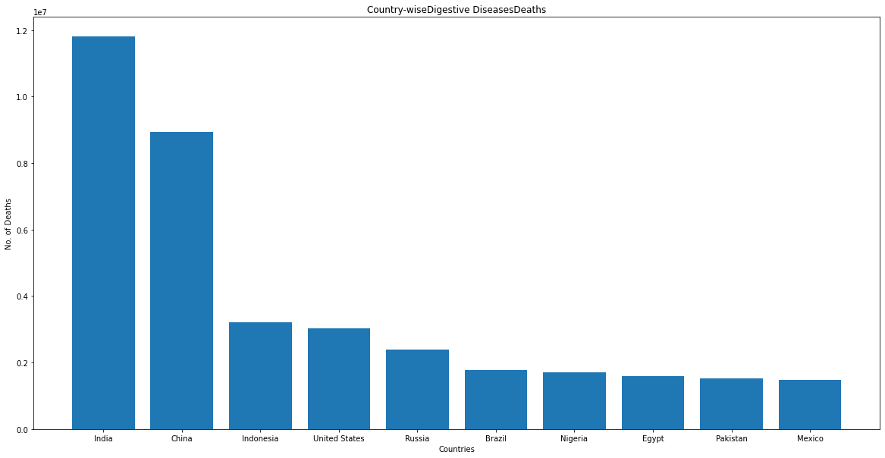

Top 10 Countries with death Counter due to Fire, Heat, and Hot Substances

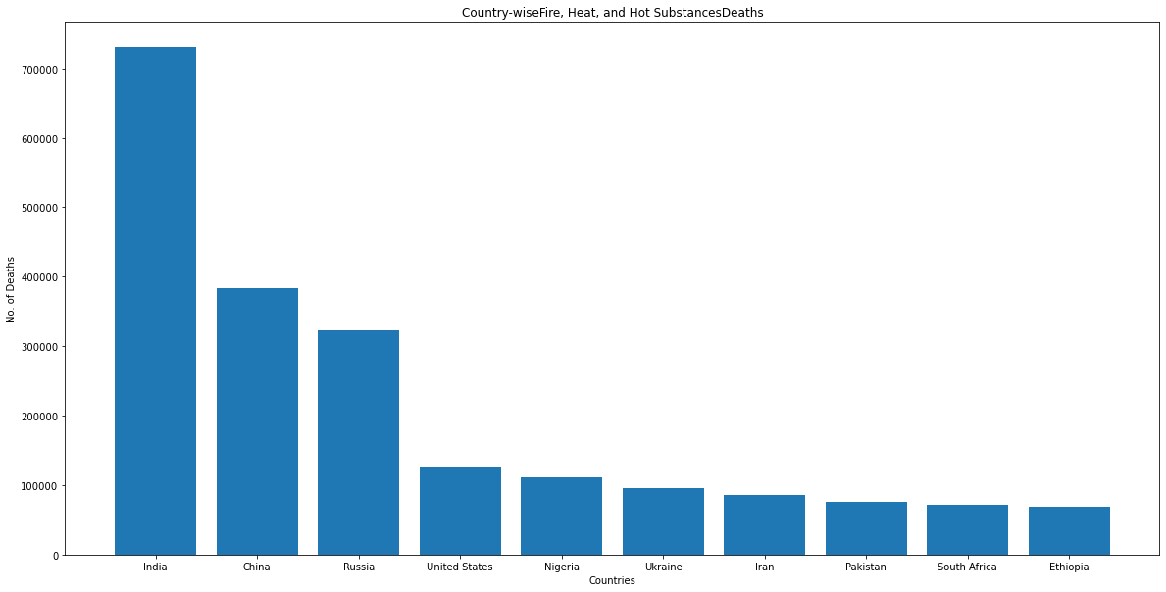

Top 10 Countries with death Counter due to Acute Hepatitis

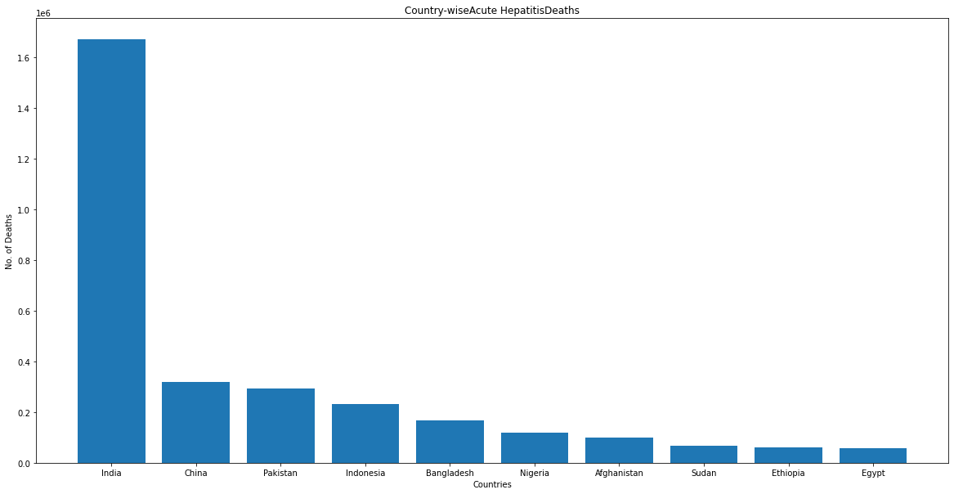

**Findings for Highest no. of deaths in particular disease in descending order for countries**

1. China and India are leading in death counts in millions for maximum no. of diseases followed by USA, Russia.
2. As we can conclude that these countries are more populated and hence death counts are more
3. We also can also say that there will be more pressure on the health care system of these countries
4. There is one notable thing in the death counts from conflict/terrorism is that in Rwanda in these 30 years more than 5 lacs, followed by countries like Syria, Iraq, Afghanistan for terrorism.

**Highest no. of deaths caused between 1990 to 2019**

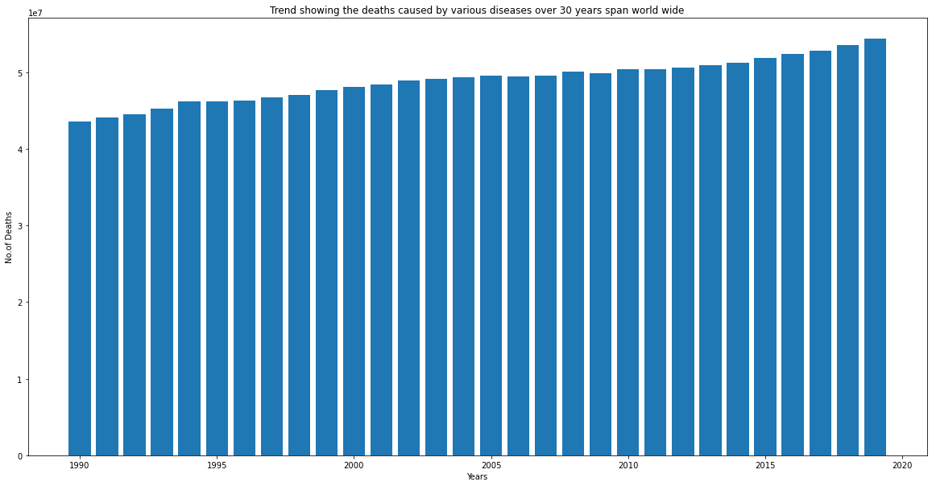

**Findings:**

1. We can see that the death count is increasing as the year by year proportional to the increase in population count.

**Graphs Showing Death Counts from 1990 to 2019 (for 30 years) caused by each disease in dataset**

Plot showing death counts over 30 years for caused due to Meningitis

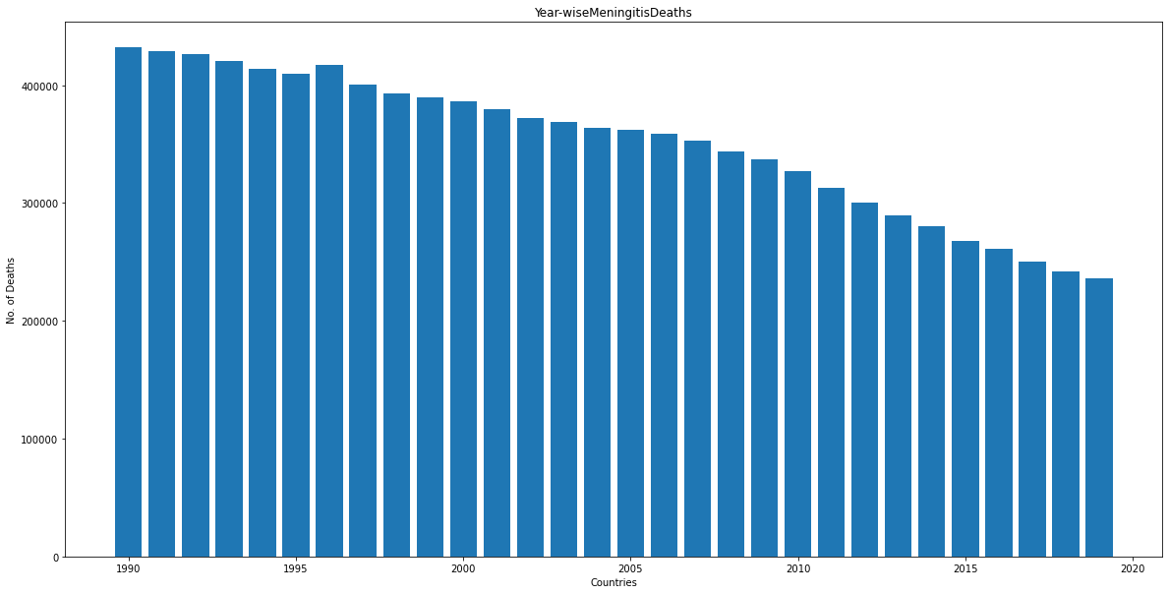

Plot showing death counts over 30 years for caused due to Alzheimer's Disease and Other Dementias

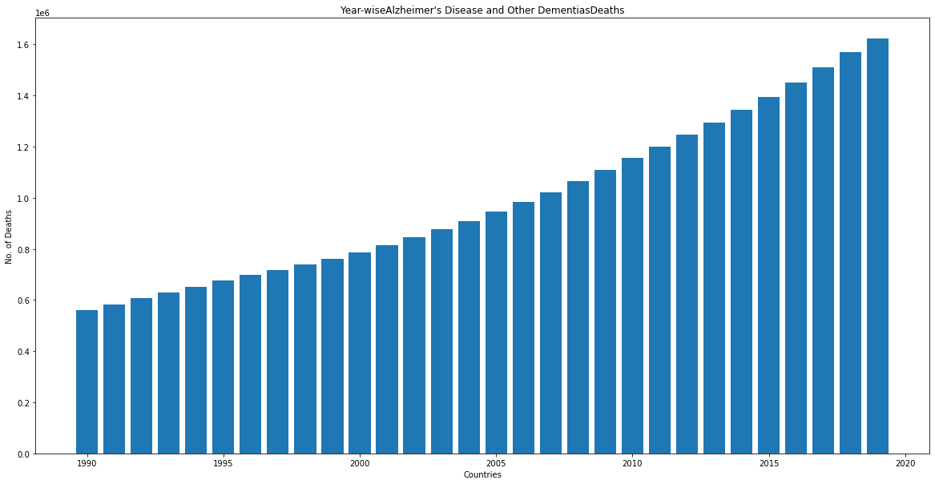

Plot showing death counts over 30 years for caused due to Parkinson's Disease

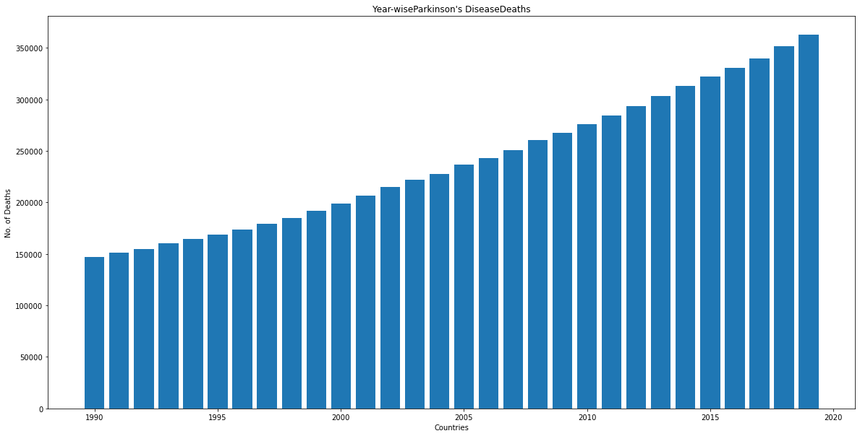

Plot showing death counts over 30 years for caused due to Nutritional Deficiencies

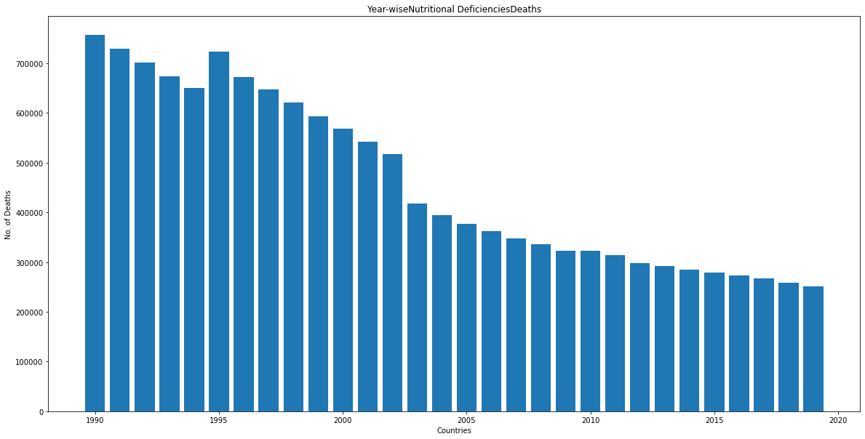

Plot showing death counts over 30 years for caused due to Malaria

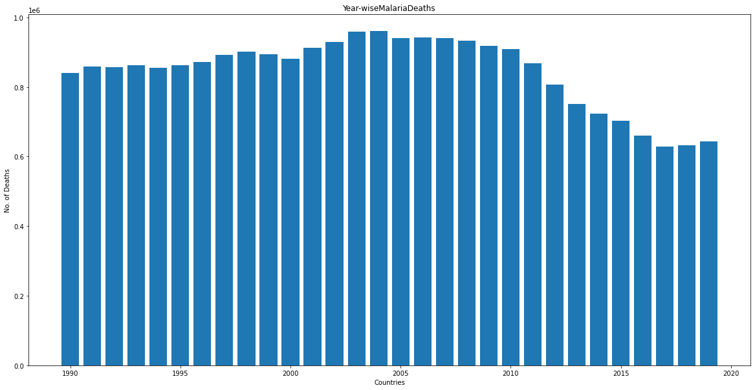

Plot showing death counts over 30 years for caused due to Drowning

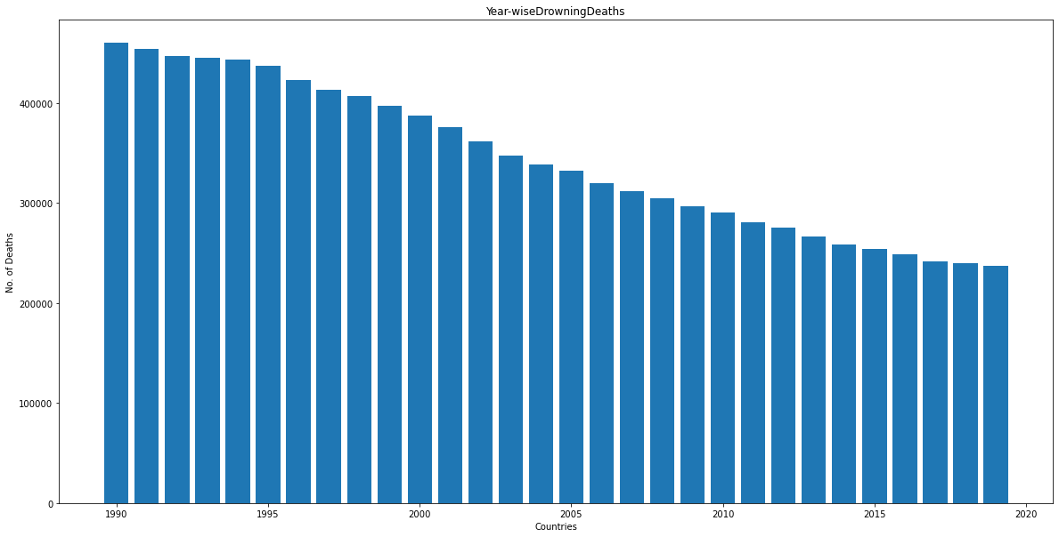

Plot showing death counts over 30 years for caused due to Interpersonal Violence

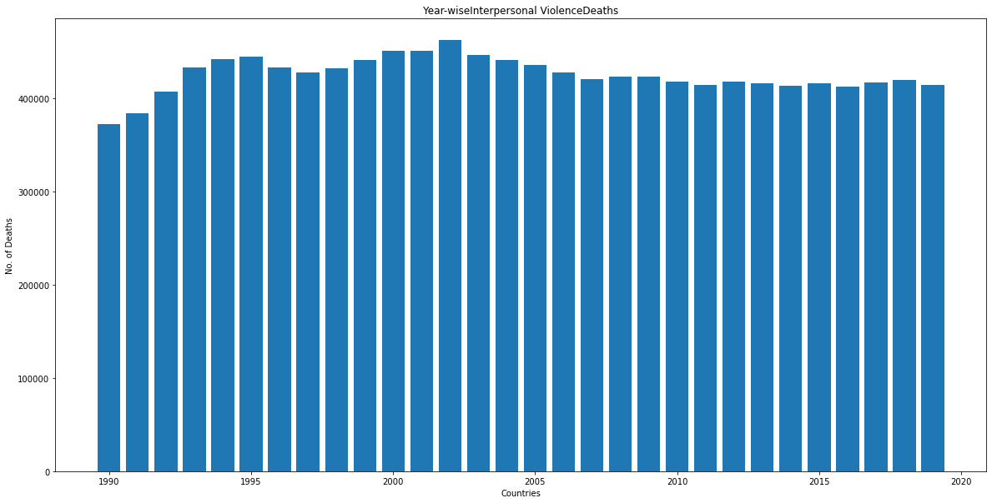

Plot showing death counts over 30 years for caused due to Maternal Disorders

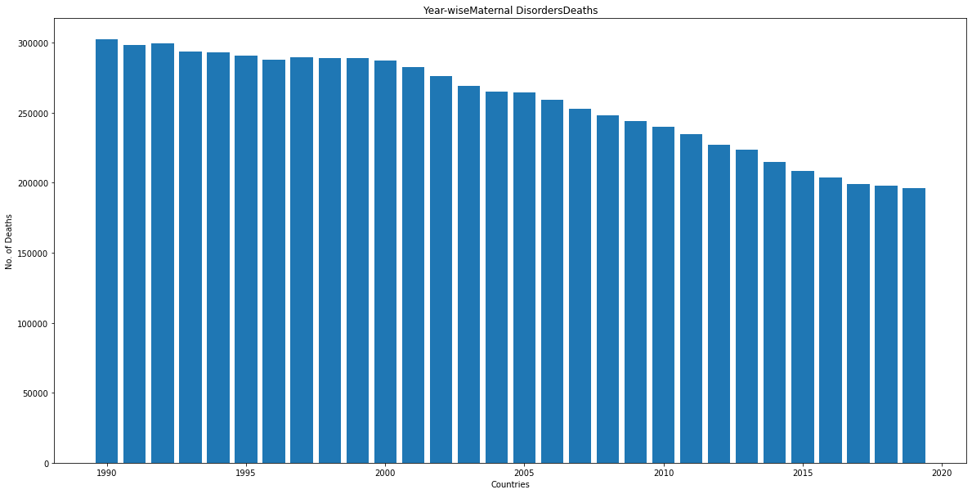

Plot showing death counts over 30 years for caused due to HIV/AIDS

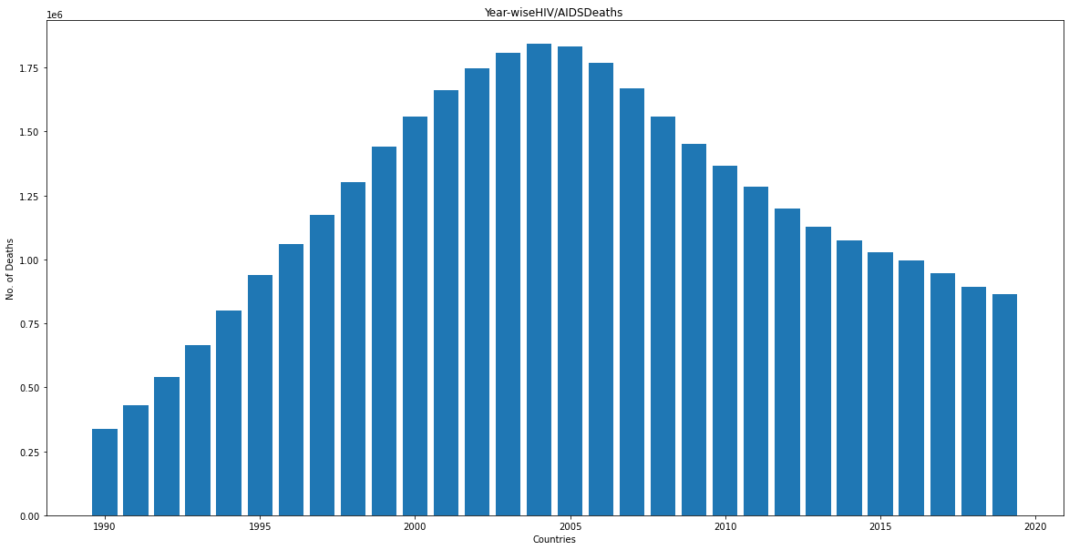

Plot showing death counts over 30 years for caused due to Drug Use Disorders

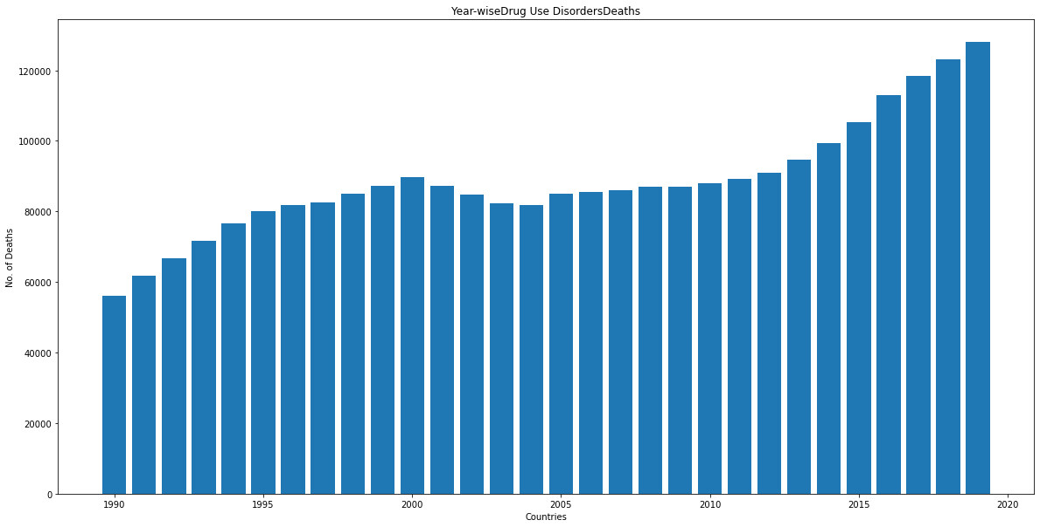

Plot showing death counts over 30 years for caused due to Tuberculosis

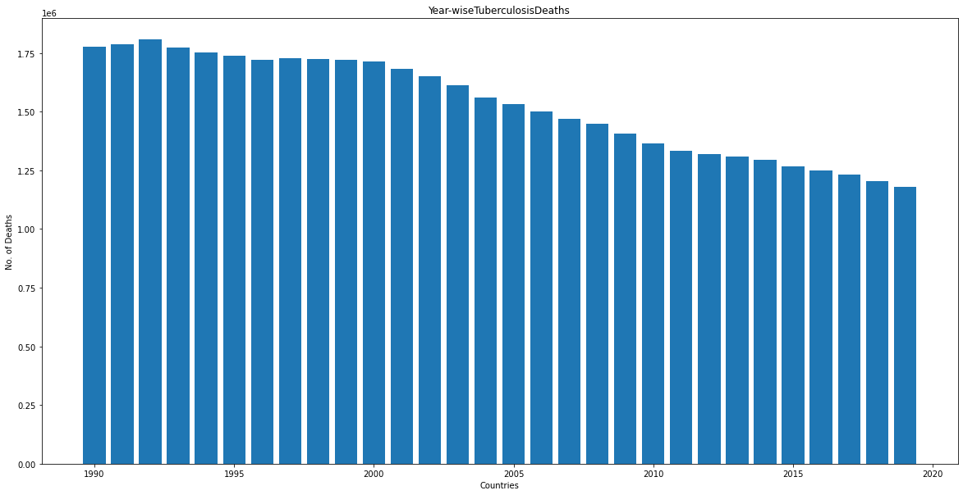

Plot showing death counts over 30 years for caused due to Cardiovascular Diseases

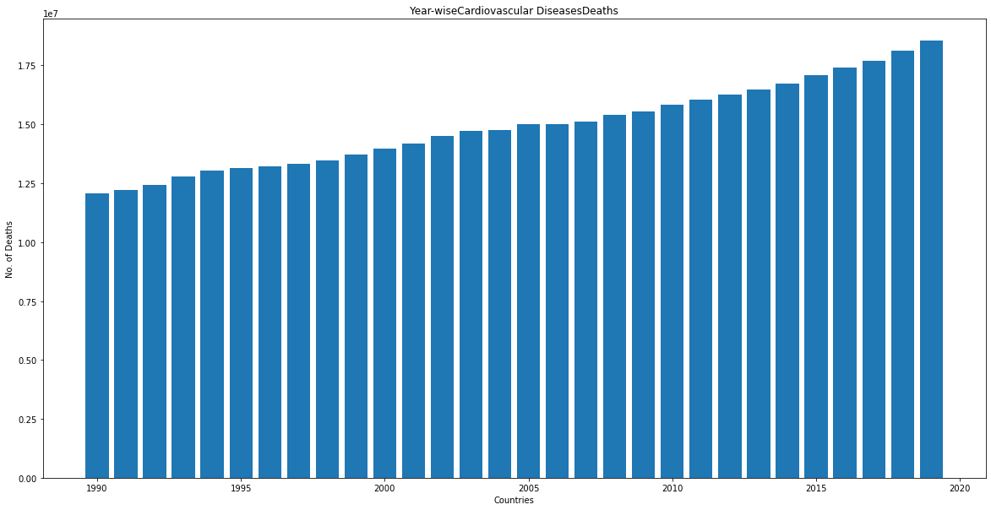

Plot showing death counts over 30 years for caused due to Lower Respiratory Infections

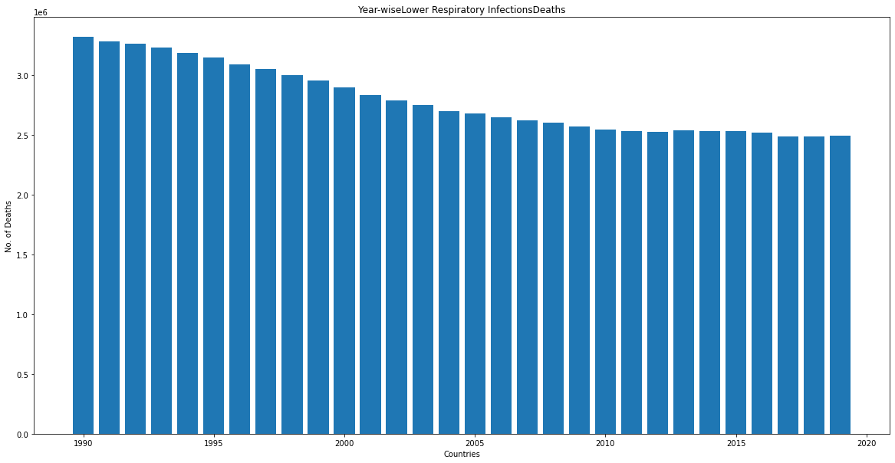

Plot showing death counts over 30 years for caused due to Neonatal Disorders

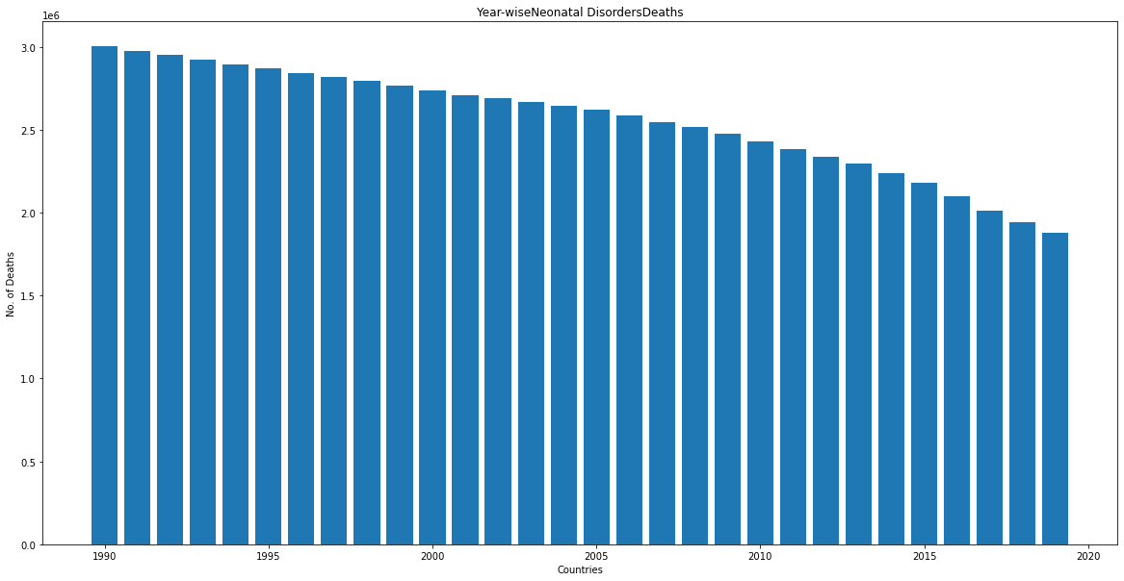

Plot showing death counts over 30 years for caused due to Alcohol Use Disorders

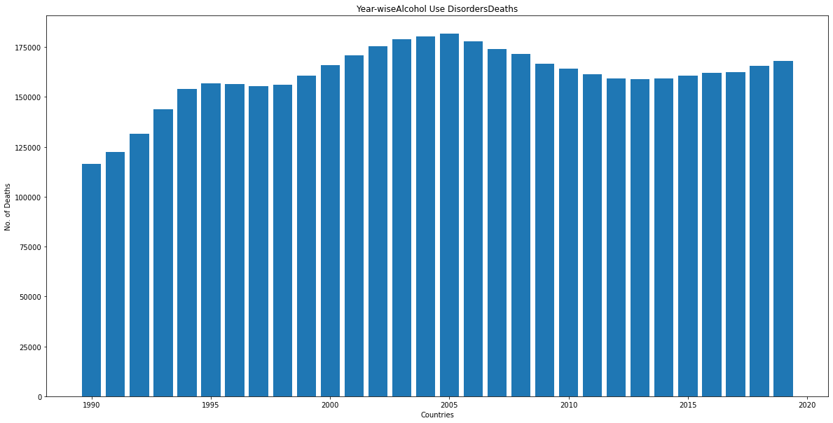

Plot showing death counts over 30 years for caused due to Self-harm

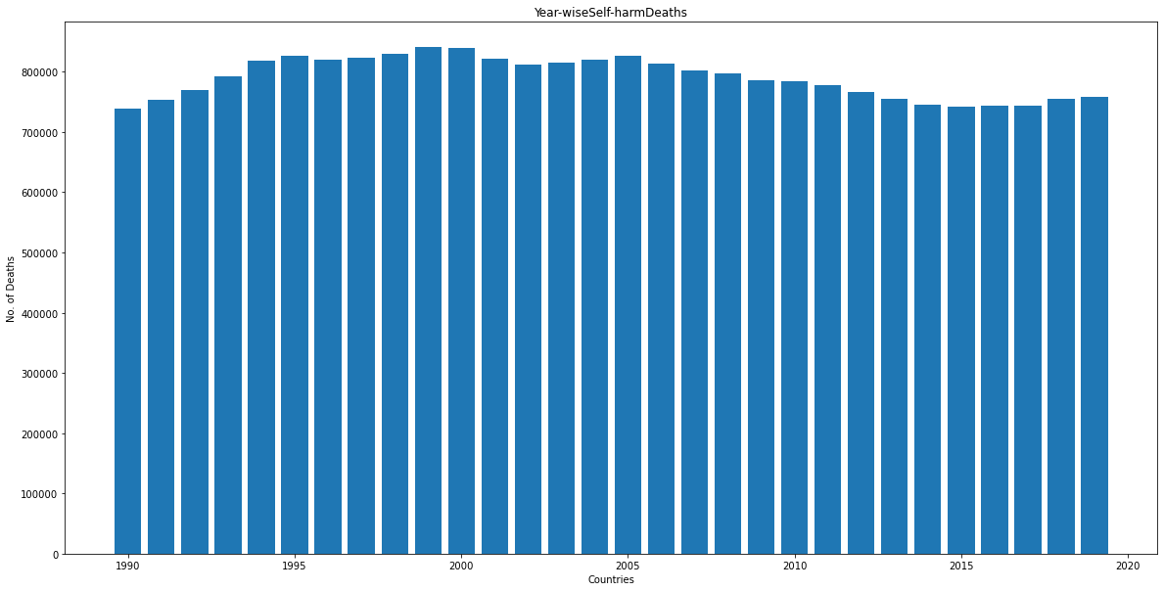

Plot showing death counts over 30 years for caused due to Exposure to Forces of Nature

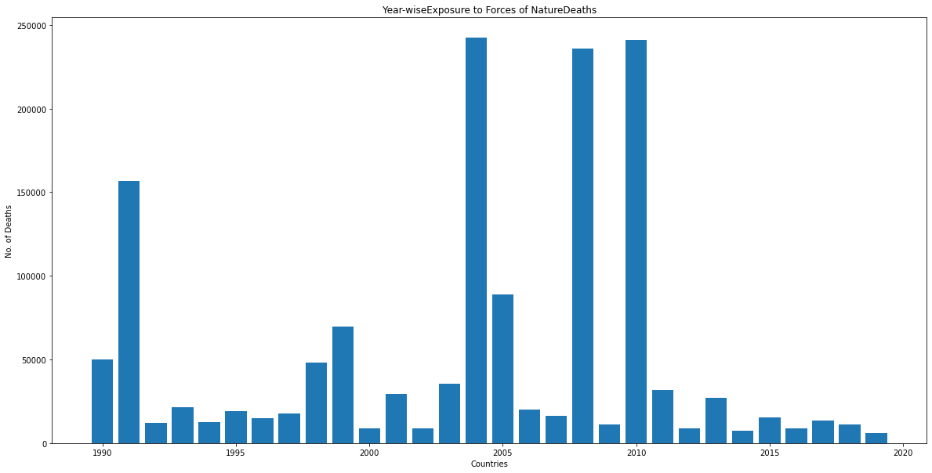

Plot showing death counts over 30 years for caused due to Diarrheal Diseases

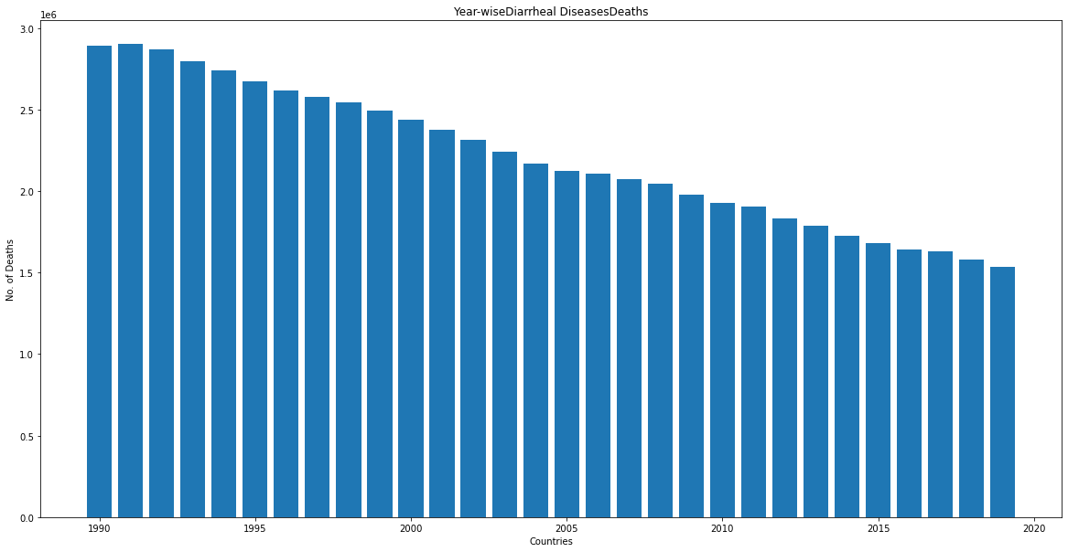

Plot showing death counts over 30 years for caused due to Environmental Heat and Cold Exposure

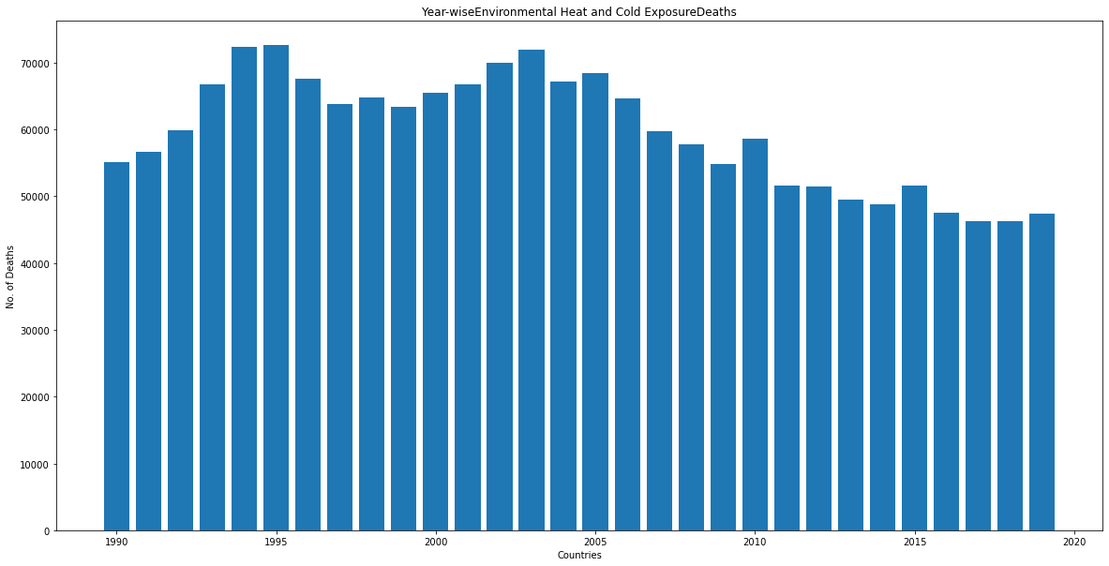

Plot showing death counts over 30 years for caused due to Neoplasms

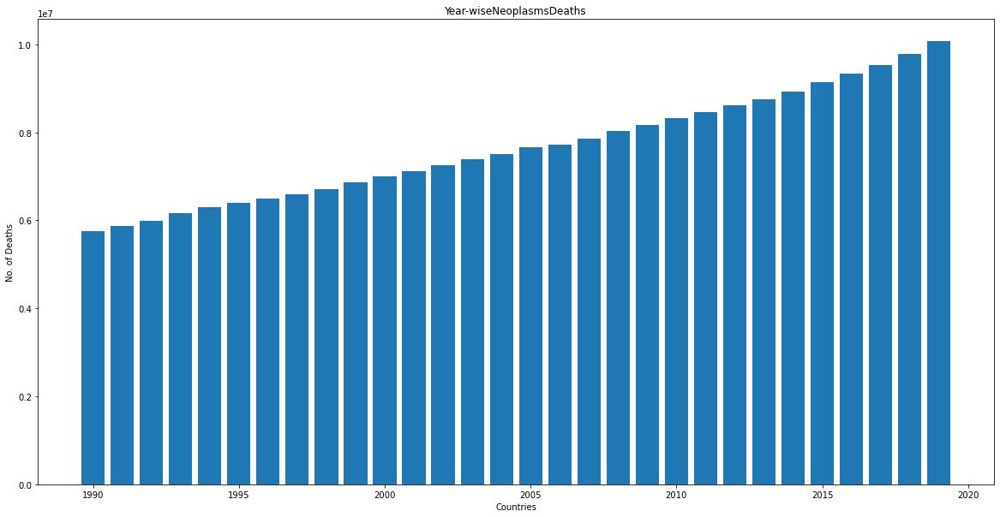

Plot showing death counts over 30 years for caused due to Conflict and Terrorism

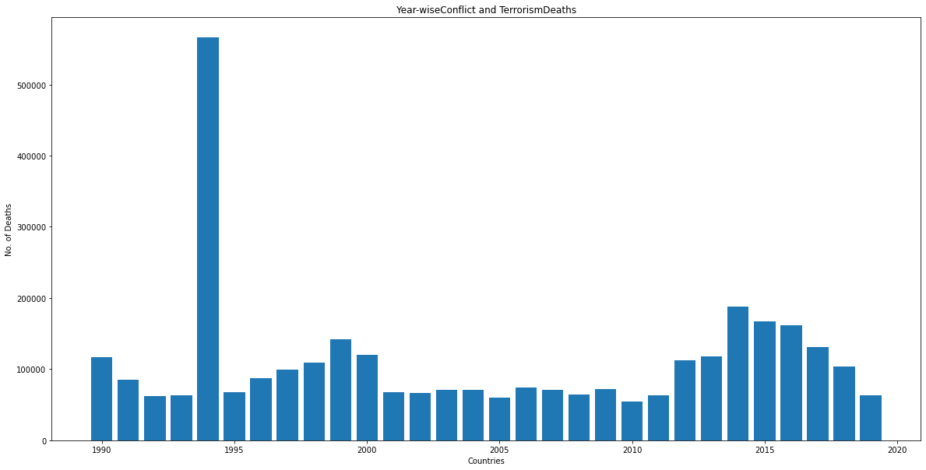

Plot showing death counts over 30 years for caused due to Diabetes Mellitus

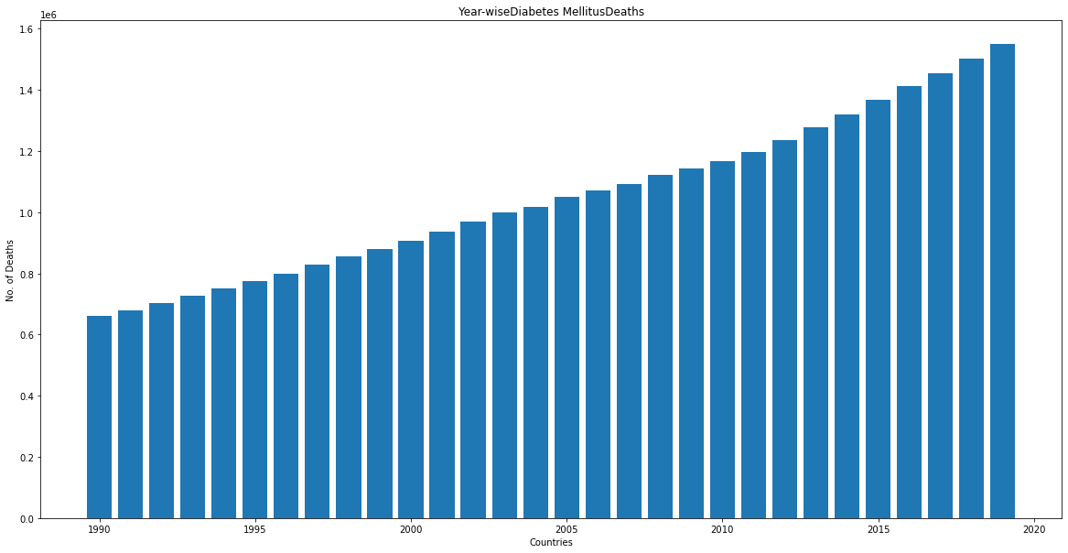

Plot showing death counts over 30 years for caused due to Chronic Kidney Disease

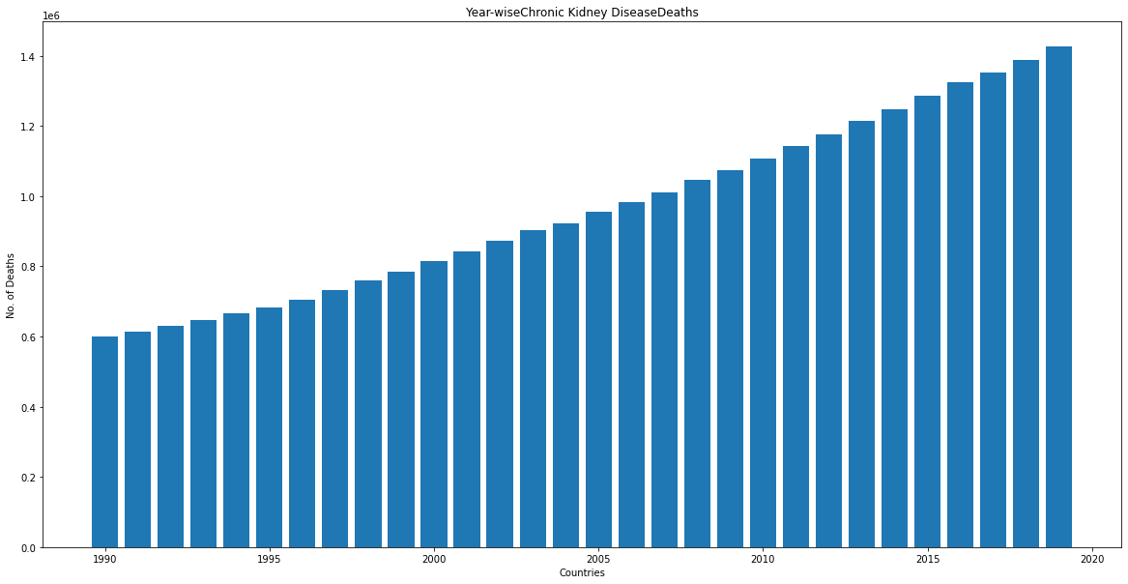

Plot showing death counts over 30 years for caused due to Poisonings

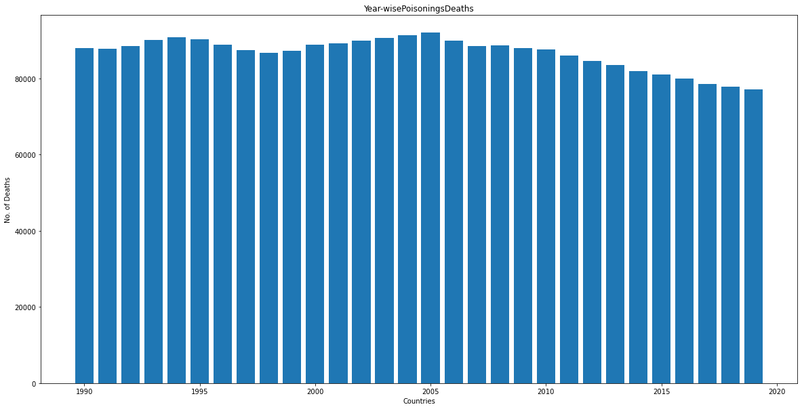

Plot showing death counts over 30 years for caused due to Protein-Energy Malnutrition

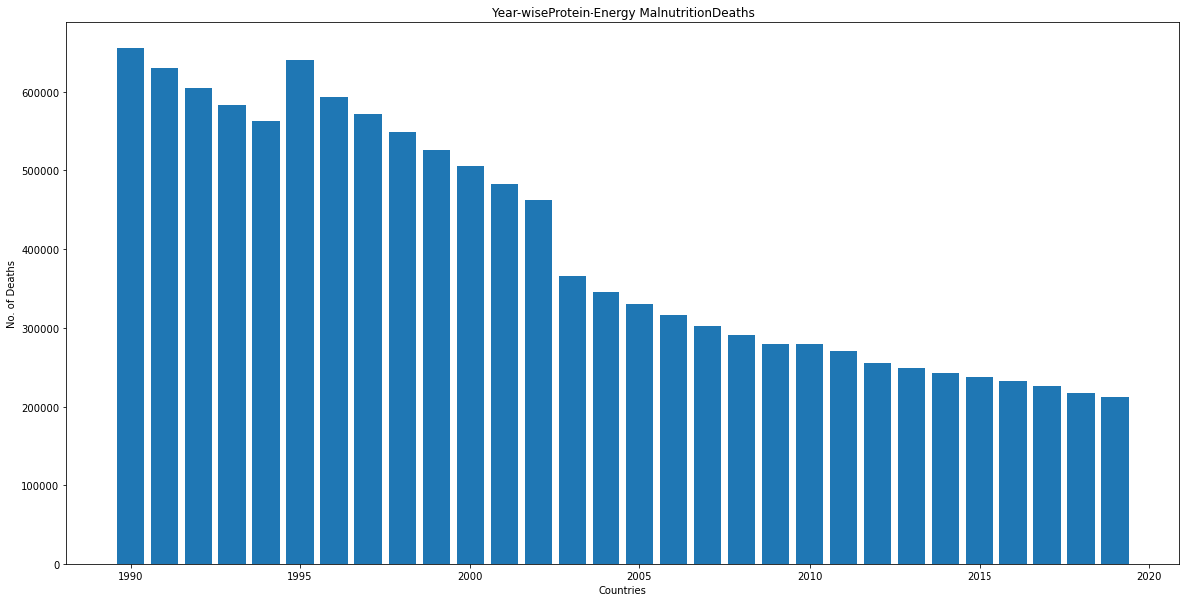

Plot showing death counts over 30 years for caused due to Road Injuries

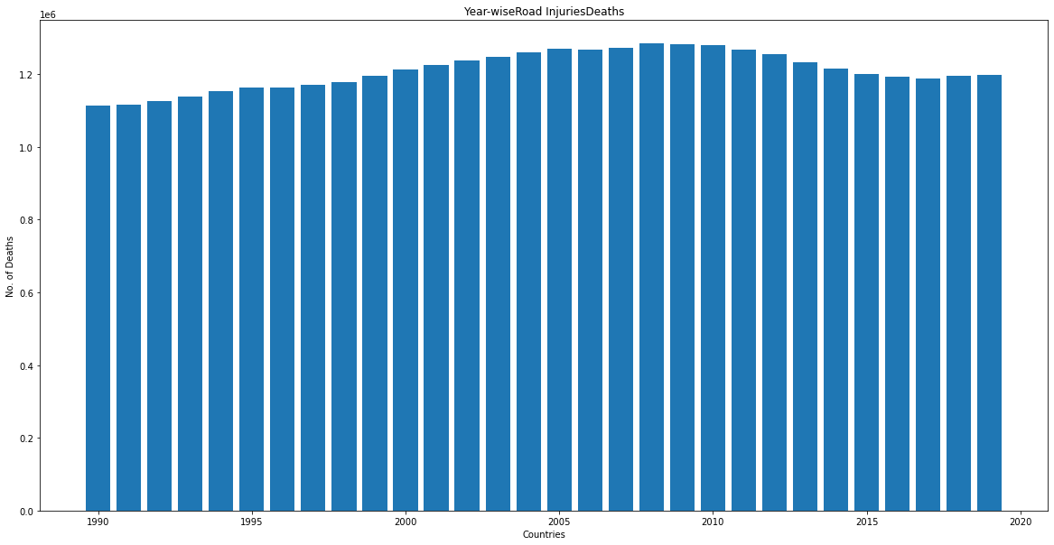

Plot showing death counts over 30 years for caused due to Chronic Respiratory Diseases

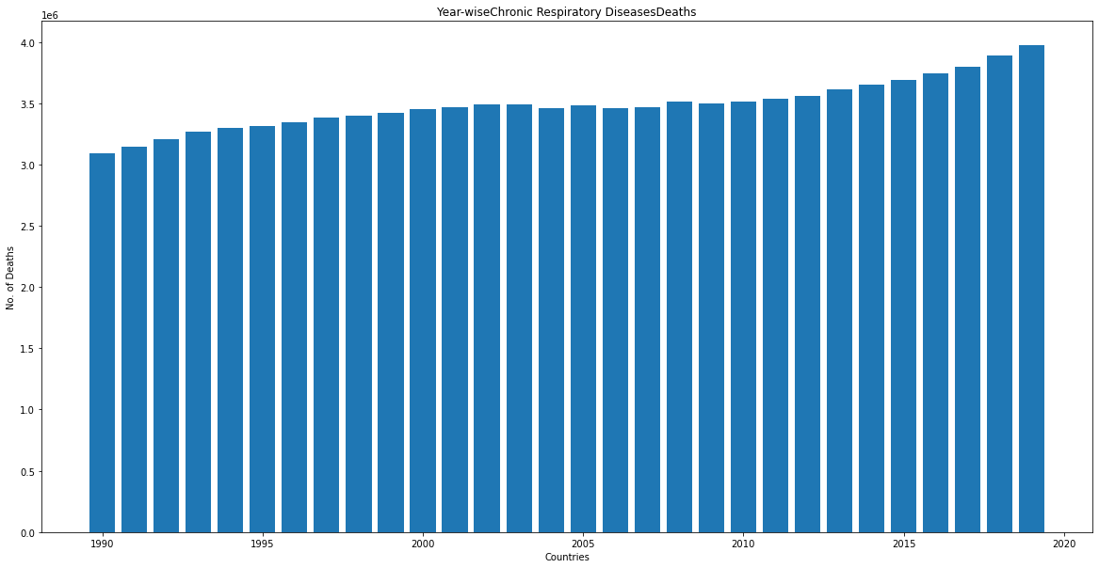

Plot showing death counts over 30 years for caused due to Cirrhosis and Other Chronic Liver Diseases

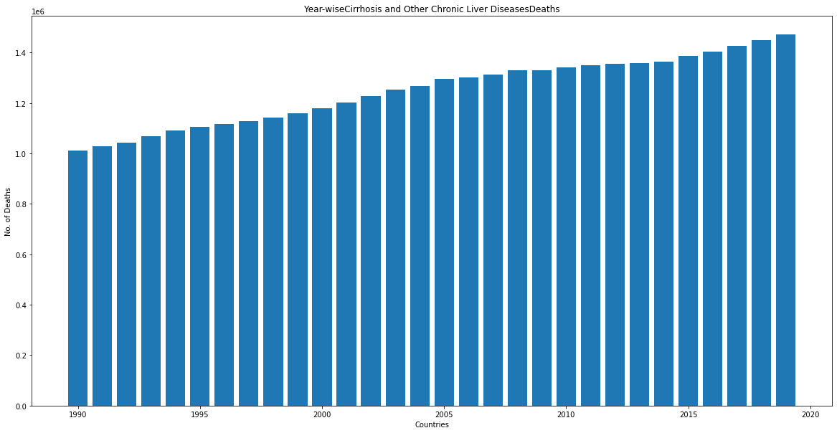

Plot showing death counts over 30 years for caused due to Digestive Diseases

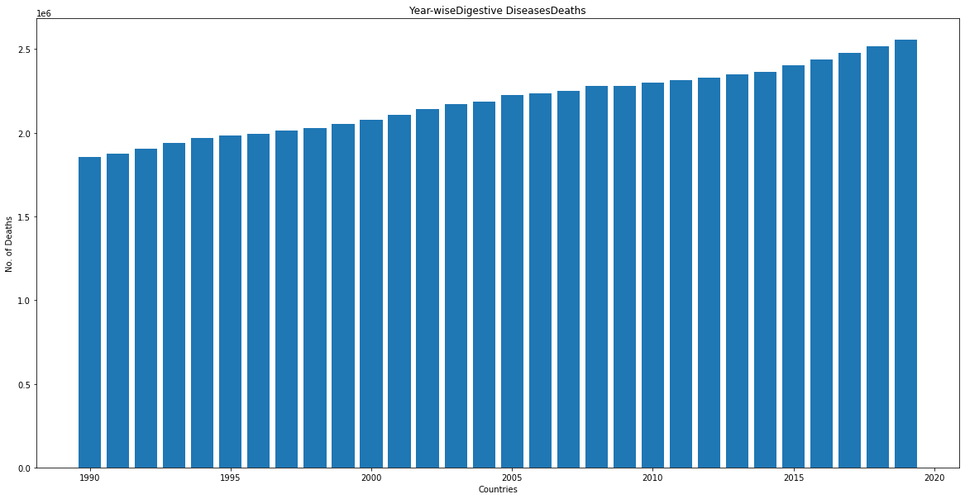

Plot showing death counts over 30 years for caused due to Fire, Heat, and Hot Substances

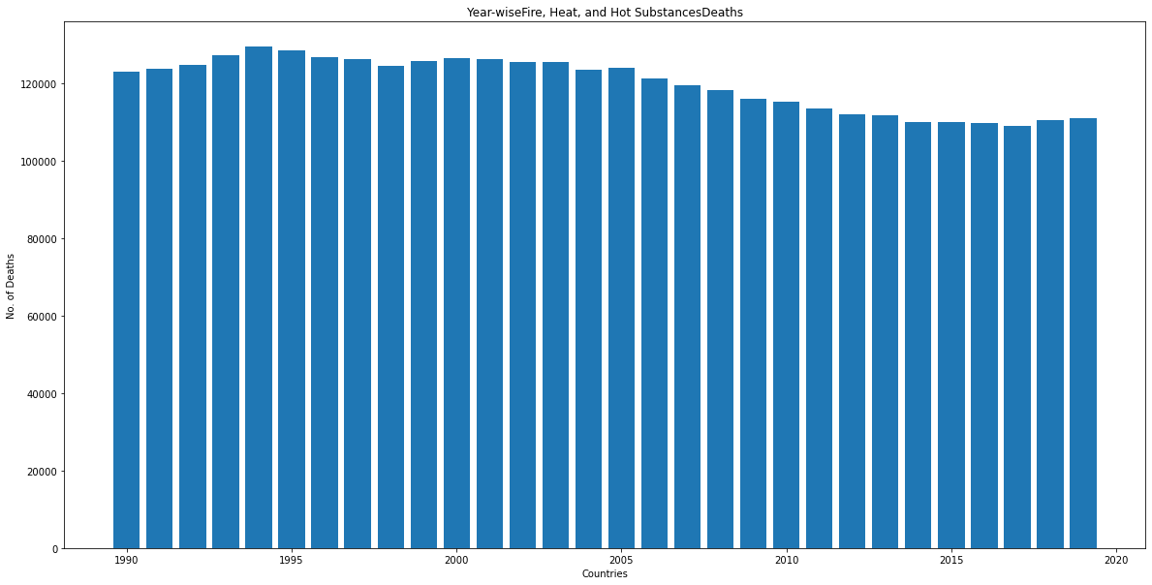

Plot showing death counts over 30 years for caused due to Acute Hepatitis

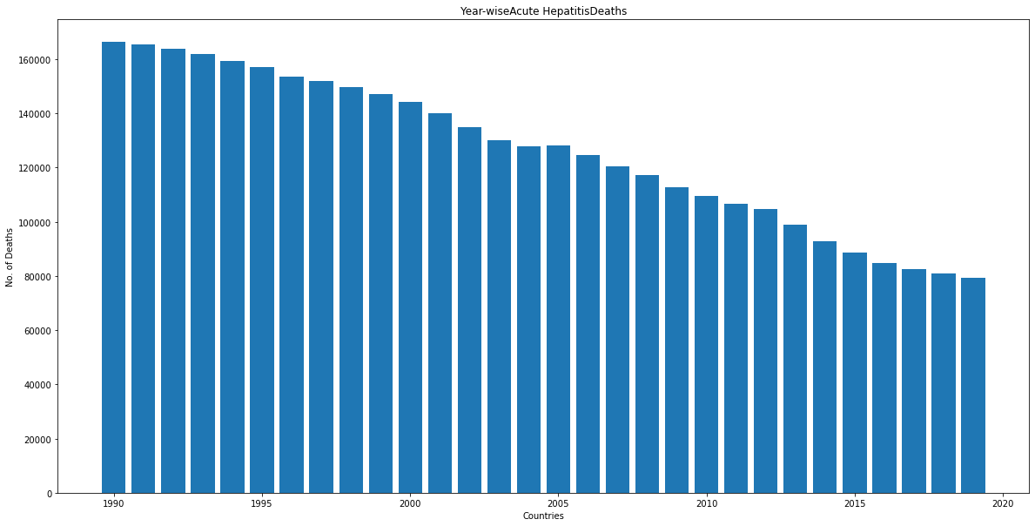

**Finding from above graphs:**

* *Following diseases shows increasing death counts over 30 year (1990-2019)*

1. Alzheimer's Disease and Other Dementias
2. Parkinson's Disease
3. Drug Use Disorders
4. Cardiovascular Diseases
5. Neoplasms
6. Diabetes Mellitus
7. Chronic Kidney Disease
8. Chronic Respiratory Diseases
9. Cirrhosis and Other Chronic Liver Diseases
10. Digestive Diseases

* *Following diseases shows decreasing death counts over 30 year (1990-2019)*

1. Meningitis
2. Nutritional Deficiencies
3. Malaria
4. Drowning
5. Maternal Disorders
6. Tuberculosis
7. Lower Respiratory Infections
8. Neonatal Disorders
9. Diarrheal Diseases
10. Poisonings
11. Protein-Energy Malnutrition
12. Acute Hepatitis

* *Following diseases shows almost same (with very little variation) death toll over 30* years

1. Interpersonal Violence
2. Alcohol Use Disorders
3. Self-harm
4. Fire, Heat, and Hot Substances
5. Road Injuries

* *The no. of deaths due to HIV/AIDS were increasing up to 2003 then the downfall is observed till 2019*
* *The no. of deaths due to Exposure to Forces of Nature (natural calamities like earthquakes, volcanic eruptions, avalanches, storms, lightning strikes, and floods) are observed high in year 1991, 2004, 2008 and 2010*
* *The trend of no. of deaths caused due to Environmental Heat and Cold Exposure (may be due to change in climate) is decreasing from 2005*
* *In the year 1994 sudden surge of death count is observed more than 1 million later on, it came to know that it is because of genocide happened in Rwanda by searching on web*.

**Overall death toll**



Findings: The overall Death Toll is increasing from 1990 to 2019 for the entire world

**Top 50 counties in Death Toll**

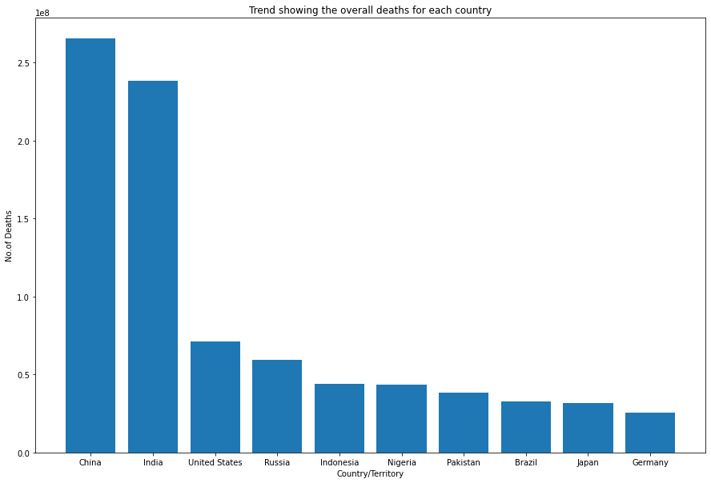

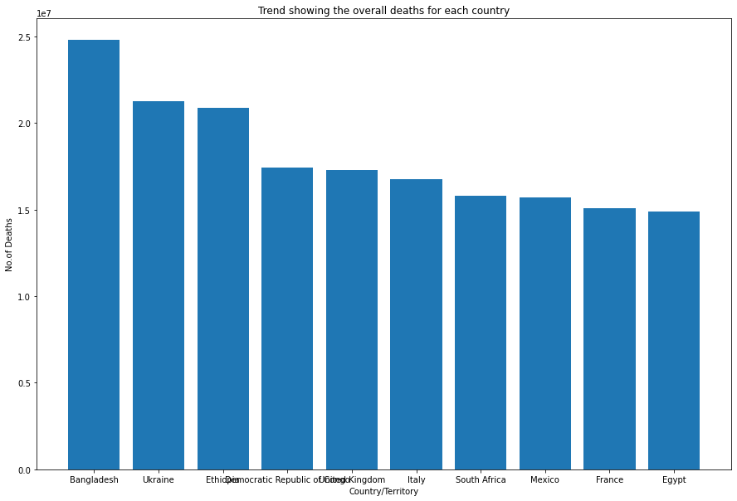

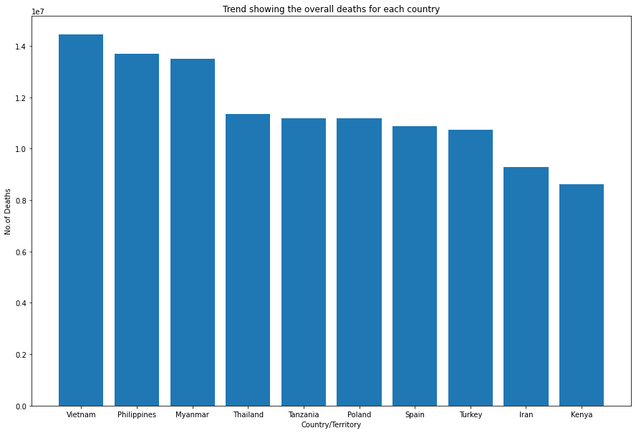

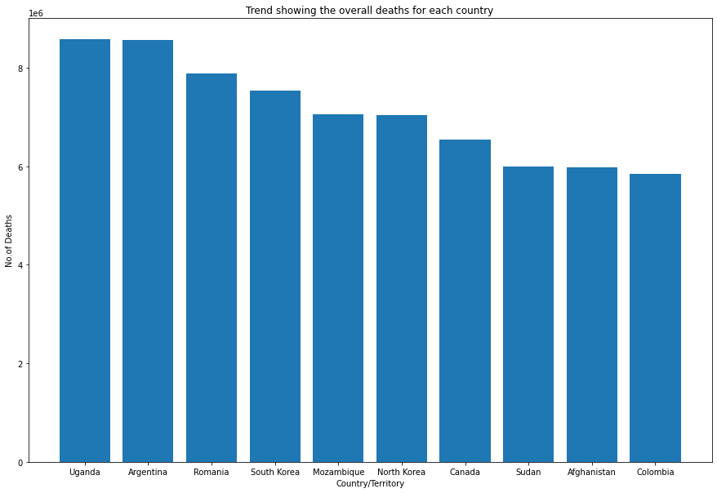

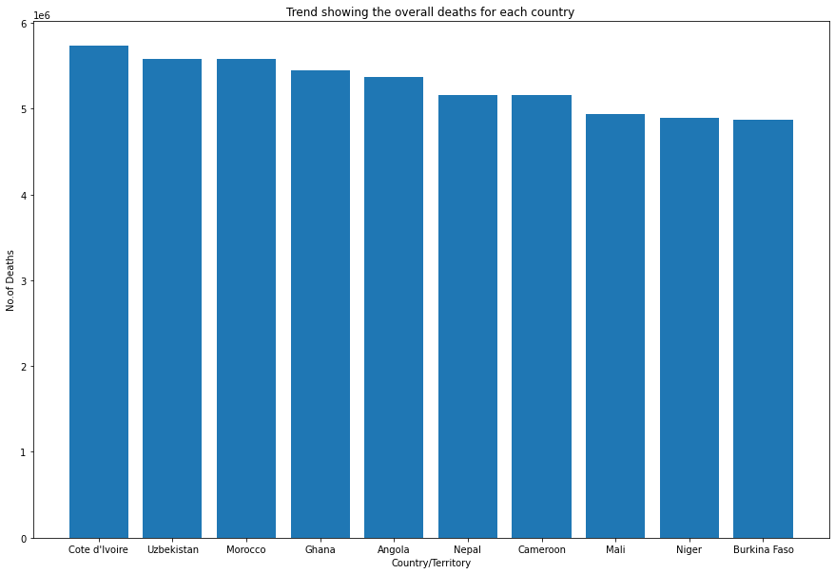

**Findings:**

1. China is ahead of all with more than 250 million of death count followed by India being second with more than 200 million.
2. USA is having death count 0.55 million being in third position, followed by Russia, Indonesia, Nigeria, Pakistan, Brazil, Japan, Germany.
3. It is seen that the death toll is proportional to the population.

**Bar graph showing no. of death in particular disease**

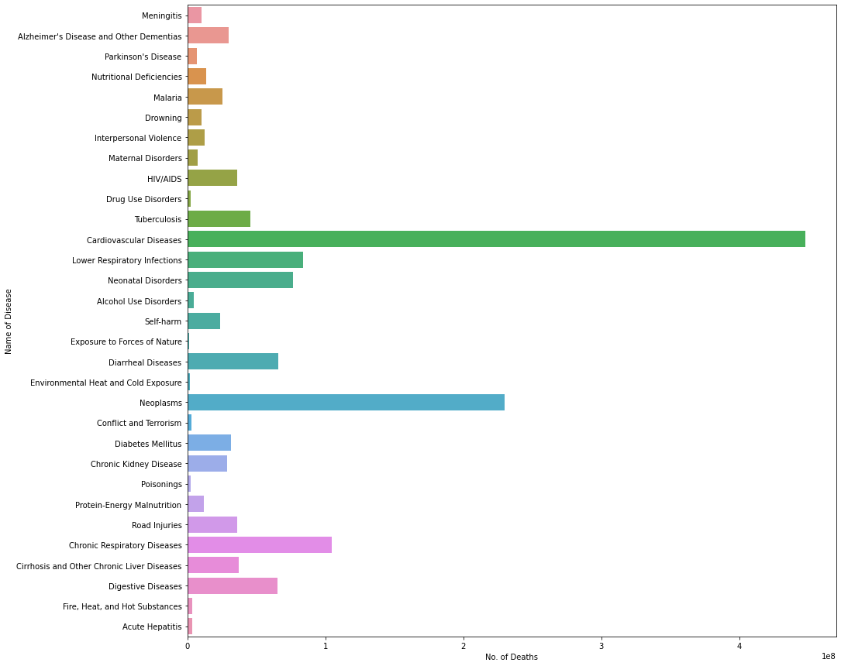

**Pie graph showing no. of Death in particular disease**

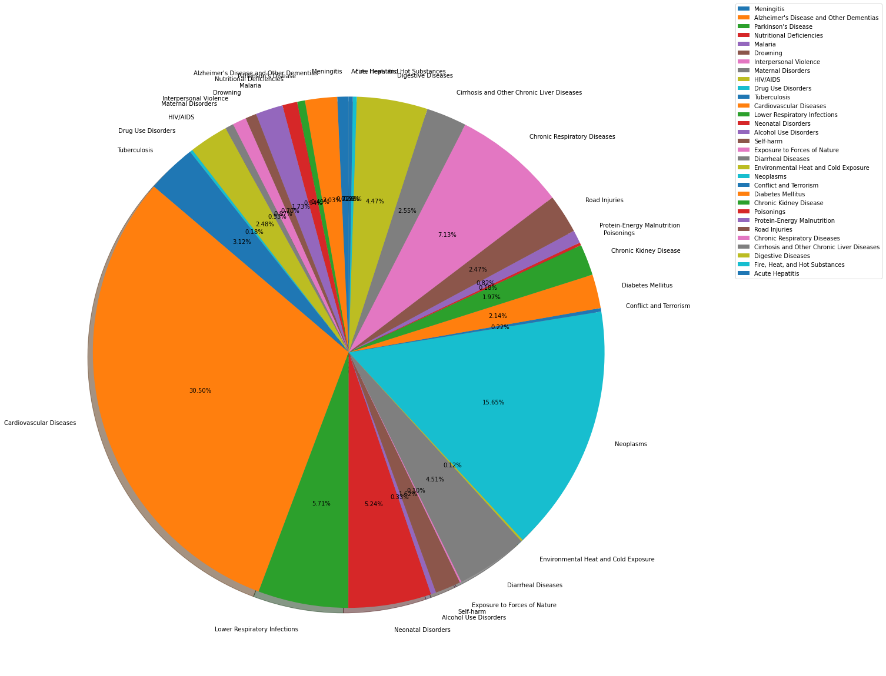

**Finding from Above two plots**

1. Cardiovascular Diseases have more no. of deaths more than 400 million, 30.50% of total deaths
2. Neoplasms have deaths 234 million, 15.65% of total deaths
3. Chronic Respiratory Diseases about 110 million, 7.13% of total death
4. Lower Respiratory Infections 90 million, 5.71% of total deaths
5. Neonatal Disorder death toll is about 85 million, 5.24% of total deaths
6. Diarrheal and Digestive Diseases have 70 million death tolls, 4.51%, 4.47% of total deaths respectively.
7. Tuberculosis with 3.12% of total deaths with 35million death toll

**Top 10 death toll countries with Top 10 death causes**

**For China**

Cardiovascular Diseases 100505973

Neoplasms 61060527

Chronic Respiratory Diseases 36676826

Digestive Diseases 8924906

Lower Respiratory Infections 8525819

Road Injuries 8350399

Alzheimer's Disease and Other Dementias 5381846

Self-harm 5078550

Cirrhosis and Other Chronic Liver Diseases 4918899

Neonatal Disorders 4353666

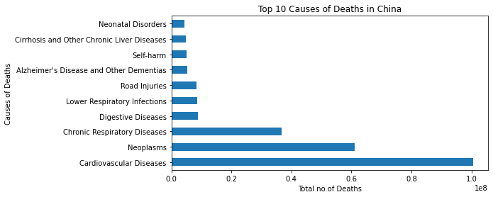

**For India**

Cardiovascular Diseases 52994710

Diarrheal Diseases 26243547

Chronic Respiratory Diseases 25232974

Neonatal Disorders 20911570

Neoplasms 17762703

Lower Respiratory Infections 16419404

Tuberculosis 15820922

Digestive Diseases 11804380

Cirrhosis and Other Chronic Liver Diseases 6294910

Self-harm 5543395

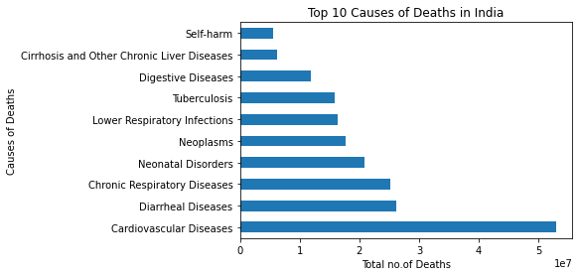

**For USA**

Cardiovascular Diseases 26438346

Neoplasms 18905315

Chronic Respiratory Diseases 4949052

Alzheimer's Disease and Other Dementias 3302609

Digestive Diseases 3026943

Lower Respiratory Infections 2248625

Diabetes Mellitus 2030631

Chronic Kidney Disease 2018497

Cirrhosis and Other Chronic Liver Diseases 1514325

Road Injuries 1359744

Name: United States, dtype: int64

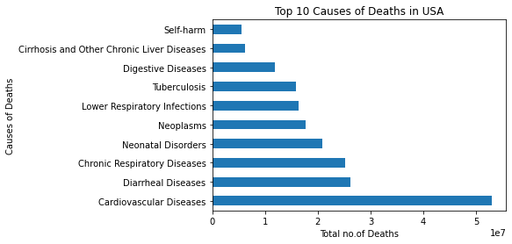

**For Russia**

Cardiovascular Diseases 33903781

Neoplasms 9079313

Digestive Diseases 2398456

Self-harm 1793855

Chronic Respiratory Diseases 1518195

Cirrhosis and Other Chronic Liver Diseases 1233608

Interpersonal Violence 1215179

Alcohol Use Disorders 1194672

Lower Respiratory Infections 1113475

Road Injuries 1067225

Name: Russia, dtype: int64

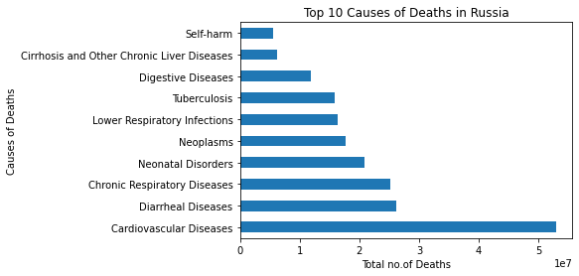

**For Indonesia**

Cardiovascular Diseases 13587011

Neoplasms 4672674

Digestive Diseases 3204787

Tuberculosis 3197011

Diarrheal Diseases 2590656

Chronic Respiratory Diseases 2559457

Cirrhosis and Other Chronic Liver Diseases 2249388

Neonatal Disorders 2238128

Diabetes Mellitus 1888549

Lower Respiratory Infections 1820769

Name: Indonesia, dtype: int64

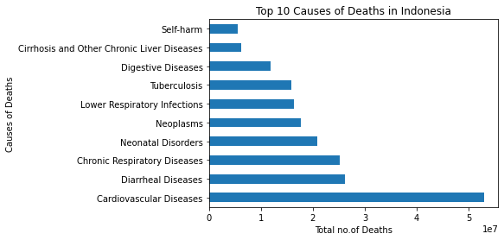

**For Nigeria**

Diarrheal Diseases 7449328

Malaria 6422063

Lower Respiratory Infections 5917528

Neonatal Disorders 5262229

Cardiovascular Diseases 4176488

HIV/AIDS 2216718

Tuberculosis 1769390

Digestive Diseases 1716202

Neoplasms 1618730

Meningitis 1520376

Name: Nigeria, dtype: int64

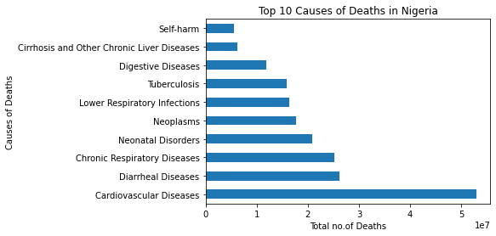

**For Pakistan**

Neonatal Disorders 7753349

Cardiovascular Diseases 7745192

Neoplasms 3633069

Diarrheal Diseases 3187522

Lower Respiratory Infections 2429268

Tuberculosis 2309703

Chronic Respiratory Diseases 2276479

Digestive Diseases 1523030

Cirrhosis and Other Chronic Liver Diseases 1039240

Chronic Kidney Disease 874990

Name: Pakistan, dtype: int64

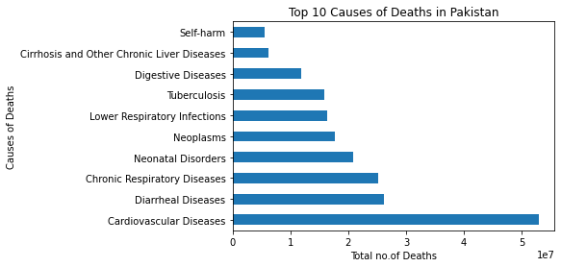

**For Brazil**

Cardiovascular Diseases 9589019

Neoplasms 5606779

Lower Respiratory Infections 1997167

Digestive Diseases 1776565

Interpersonal Violence 1762967

Chronic Respiratory Diseases 1743233

Neonatal Disorders 1667293

Road Injuries 1352192

Diabetes Mellitus 1315755

Cirrhosis and Other Chronic Liver Diseases 927027

Name: Brazil, dtype: int64

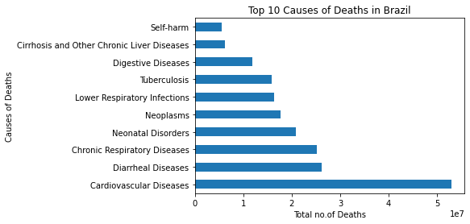

**For Japan**

Neoplasms 10530449

Cardiovascular Diseases 9210437

Lower Respiratory Infections 2659196

Alzheimer's Disease and Other Dementias 2638908

Digestive Diseases 1463405

Chronic Respiratory Diseases 1231229

Chronic Kidney Disease 966881

Self-harm 861712

Cirrhosis and Other Chronic Liver Diseases 755502

Road Injuries 327979

Name: Japan, dtype: int64

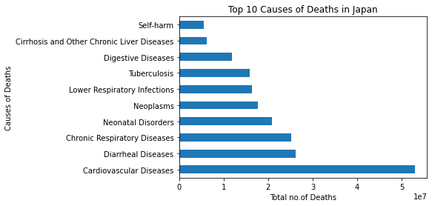

**For Germany**

Cardiovascular Diseases 10819770

Neoplasms 7325650

Digestive Diseases 1335653

Chronic Respiratory Diseases 1117582

Alzheimer's Disease and Other Dementias 1114977

Cirrhosis and Other Chronic Liver Diseases 654268

Diabetes Mellitus 621575

Chronic Kidney Disease 616900

Lower Respiratory Infections 603119

Self-harm 377986

Name: Germany, dtype: int64

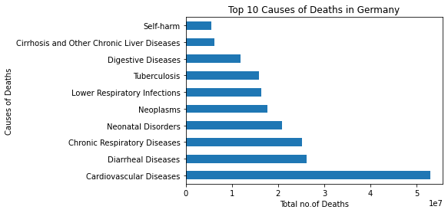

**Findings:**

1. Cardiovascular Diseases are at top for death toll in all the top 10 countries
2. Diarrheal Diseases being the second one except China
3. Chronic Respiratory Diseases becomes the third and Neoplasms and neonatal becomes fourth